My Independence:

EQUALs Engaging in tasks

PSHE Association: Health & Wellbeing → Responsibility

LO: Pupils will complete structured tasks
NC: PSHE

My Sensory Play:

EQUALs Fabrics and textures
LO: Pupils will explore props linked to stories.
NC: Science

My Communication:

EQUALs Responding to stories
LO: Pupils will respond to texts.
NC: English

My Physical Well-Being:
EQUALs Movement
LO: Pupils will develop coordination through activity.
NC: PE

MOVE
Sensory Swimming
Sensory Kingdom
My Creativity:

EQUALs Story-based art
LO: Pupils will create artwork inspired by stories.
NC: Art / Music

Maths:
Daily basic skills focusing on Number through the Little Big Maths approach
Geometry/Measure- EQUALs Shape and Space
PfA Skills Builder:
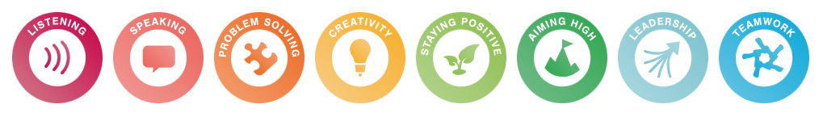

Oliver Jeffers
KS3
Focus Subjects:
English, Art

RE:

EQUALs 3.7.5 What can religious stories teach us about good and evil?

LO: Pupils will explore religious stories to understand ideas of good and bad choices, recognising how actions can affect others through shared storytelling, discussion and role play.
NC: Understand that religious stories teach moral lessons about right and wrong, and how people should treat others

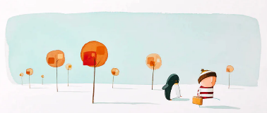
My Outdoor School:
EQUALs Story exploration outdoors
LO: Pupils will engage in outdoor storytelling
NC: Geography

English:
Daily basic skills focusing on Read Write Inc Phonics and reading skill development
Texts:
Fiction: The Day the Crayons Quit and how to catch a star
Non- Fiction: Here We Are: Notes for Living on Planet Earth and Here We Are: Book of Animals
Poetry: Begin again and What we’ll build

