My Independence:

EQUALs Self-regulation

PSHE Association: Health & Wellbeing → Independence in daily life

LO: Pupils will manage their own emotions.
NC: PSHE

My Sensory Play:

EQUALs Regulation strategies
LO: Calming sensory work.
NC: Science

My Communication:

EQUALs Expressing needs
LO: Pupils will communicate needs effectively.
NC: English

My Physical Well-Being:
EQUALs Fitness
LO: Pupils will maintain physical wellbeing.
NC: PE

MOVE
Sensory Swimming
Sensory Kingdom
English:
Daily basic skills focusing on Read Write Inc Phonics and reading skill development
Texts:Fiction: The Feeling Good Club: Smash Your Worries, Bella! by Kelly McKain
Non- Fiction: Being Me: A Collection of Educational Poems for Kids by Rachael Thomas
Poetry: The Sad Ghost Club by Lize Meddings
My Creativity:

EQUALs Creative relaxation
LO: Pupils will use creativity for relaxation.
NC: Art / Music

RE:

EQUALs 4.10.3 Can we be reflective? What is Spirituality?

LO: Pupils will explore what it means to be reflective and develop an awareness of spirituality through calm experiences, sensory activities and opportunities to think about feelings, nature and the world around them.

NC: Understand that people reflect on life, beliefs and experiences in different ways and that spirituality can involve thinking about meaning, feelings and the world

My Outdoor School:
EQUALs Outdoor calming activities
LO: Pupils will regulate in outdoor environments.
NC: Geography

Maths:
Daily basic skills focusing on Number through the Little Big Maths approach
Geometry/Measure- EQUALs Length, Size and Height
PfA Skills Builder:
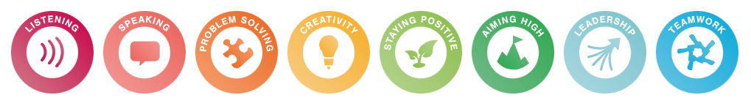

Relaxation
KS4
Focus Subjects:
PE, PSHE

