SELF CARE AND INDEPENDENCE
Daily: Personal Hygiene Routines eg toothbrushing, hand washing, hair care, personal care Feeding/drinking programmes
Developing a sense of self – mirror work

Weekly: Personal Development
PSHE Association – Self Awareness – Things That we are good at
Collective Worship- RE EQUALS- Unit 1.1.1- Myself, Who am I? Why am I unique?

L.O- by the end of the half term, pupils will develop independence, self-awareness and personal wellbeing through a range of activities and routines.

PHYSICAL
Daily:
Positioning, Physiotherapy Programmes, Sensory Steps
Weekly:
Hand warm up programmes, Sensory Kingdom

Dance Focus – Dance Massage, Dance Tutors
Rebound Therapy

Sensory Swimming – Musical Hydrotherapy

L.O- At the end of this half term, pupils will show an increased awareness of their body parts and show increased control over purposeful movements.

MOVE:
Move Programmes to include individual targets
OT and OTA will take pupils out for input and model techniques to staff
Physiotherapy programmes,
Postural management plans
OT Programmes

COGNITION
Daily Basic Skills – Sensory Maths, number rhymes
Switch skill progression
Eye gaze skills
Maths massage – All about me
Maths Focus – Shape
Early maths skills – reaching, choosing, one more one less (number songs)
Switch It Jigsaw, favourite ICT games and resources

NC Maths – practice counting, identify one more, one less

L.O- by the end of the half term pupils will develop understanding, attention and early learning skills through exploration, choice-making and interactive activities.

Enrichment:
Hair Salon exploration
Pamper session exploration
Spa/beauty salon visit
Science Club

Theme Title: All About Me!

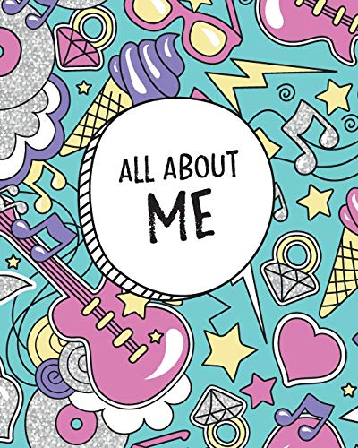

Autumn 1
Yellow Class

Texts:
Fiction: This is Me- Story Massage

Non-fiction: Sensory Experience- My Body, My Day

Poetry : All About Me

COMMUNICATION
SALT Programmes, DBS – Phase 1 Early Phonics / Pre Phonics, Sensory mark making activities, Exploring tactile/button books/ sensory stories, Making choices, responding to questions/ making decisions
Personalised sensory stories ‘All About Me’
Sound Therapy- Sound Bath/ Sound Beds, Showing consistent responses to music and instruments
Music – Sparkyard, Music Tutors, Music Projects
Whole Shabang, Resonance Board and equipment
British Values – democracy – Voting, evaluation
Eye Gaze, NC English – apply phonic knowledge, develop a pleasure in reading, maintain attention and participate actively in conversations)
L.O. – By the end of the half term, pupils will develop understanding, attention and early communication skills through exploration, choice-making and interactive activities.

