Humanities:
History –
(NC) Pupils should be taught about:
Changes in Britain from the Stone Age to the Iron Age
-late Neolithic hunter-gatherers and early farmers, for example, Skara Brae
(Croods/Early man)
LO: Pupils will explore life in prehistoric Britain, developing awareness of how early humans lived, including hunting, gathering and farming, and recognising how life has changed over time.

Geography – Natural disasters
(NC) Describe and understand key aspects of physical geography, including: climate zones, biomes and vegetation belts, rivers, mountains, volcanoes and earthquakes, and the water cycle
LO: Pupils will explore natural disasters, developing awareness of physical features of the Earth and how events such as volcanoes, earthquakes and extreme weather affect environments.

RE –
(Equals)
(2.3.5) Why is Jesus a special person (‘The Star’ film)
(2.6.1) How and why should we care for our world
LO: Pupils will explore why Jesus is important to Christians through stories, recognising themes such as kindness, helping others and special events.
LO: Pupils will explore why caring for the world is important, recognising how people show responsibility for the environment.

Computing -
Computer Science, Desktop publishing, scratch animation.
LO: Pupils will explore creating digital content and simple programs, developing understanding of sequencing and using tools to communicate ideas.

Personal Development:
Life skills – I can explore my feelings (Keeping safe)
Keepings safe online

LO: Pupils will explore and recognise their own feelings, developing the ability to respond safely and appropriately in different situations.

PSHE – Self-Awareness -– PSHE Association
1.Things we are good at (Frozen/Moana)
2. Kind and Unkind behaviours
3.Getting on with others
(SA1,2&3)
LO: Pupils will develop skills in getting along with others, including sharing, turn-taking and positive interaction.

RSE – Knowing me
Likes and dislikes
Families
LO: Pupils will develop self-awareness by identifying their likes and dislikes and recognising that families can be the same or different.

Arts:
DT – EQUALS Story Books
LO: Pupils will design and create simple story books, developing ideas through planning, making and adapting their work to communicate meaning.
(NC) Use research and criteria to develop products which are fit for purpose

Art – Pop Art
LO: Pupils will explore Pop Art styles, using bold colours, patterns and images to create their own artwork inspired by artists.
(NC) Use sketchbooks to collect,
record, review, revisit & evaluate ideas

Music – Music in film
LO: Pupils will explore how music is used in films, developing awareness of how sounds create mood, emotion and meaning.
(NC) Appreciate wide range of live & recorded music.
Begin to develop understanding of history
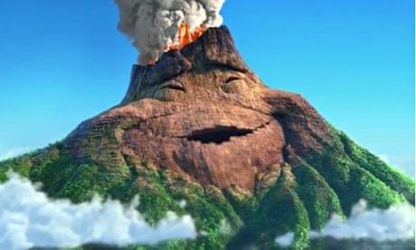
Physical Development:

PE - Gymnastics
(NC) Develop flexibility & control in gym, dance & athletics. Take part in Outdoor & Adventurous activities
LO: Pupils will develop flexibility, balance and control through gymnastics and outdoor activities, exploring different movements and responding to physical challenges.

Swimming
Sensory Kingdom
Sensory Circuit
Science:
Electricity–
(NC) Electricity: simple circuits & conductors
Construct a simple series electrical circuit, identifying and naming its basic parts, including cells, wires, bulbs, switches and buzzers.
LO: Pupils will construct and explore simple electrical circuits, identifying basic components and recognising how electricity flows to make devices work.

Animals inc Humans – Being strong & healthy
(NC) Biology - Life cycles of plants & animals (inc. mammal, insect, bird, amphibian). Describe changes as humans develop & mature
LO: Pupils will explore how living things grow and change, developing awareness of life cycles and understanding how to stay healthy through diet, exercise and self-care.
English:

Daily basic skills focusing on Read Write Inc Phonics and reading skill development

Texts:
Poetry – Dr Seus / The cat in the hat
Fiction – DreamWorks stories
Non-fiction – Volcanos and earthquakes
Maths:
Daily basic skills focusing on Number through the Little Big Math’s approach

Geometry – Patterns

Measure – Weight & volume
PfA Skills Builder:
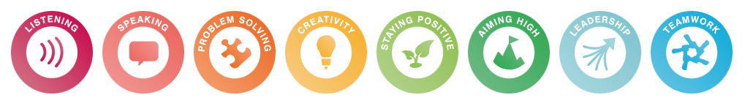

Amazing Animations

KS2

Focus Subjects:
Personal Development

