My Independence:

EQUALs Managing activities

PSHE Association: Health & Wellbeing → Decision making

LO: Pupils will manage participation in different tasks.
NC: PSHE

My Sensory Play:

EQUALs Lights and sounds
LO: Pupils will explore sensory stimuli.
NC: Science

My Communication:

EQUALs Social interaction
LO: Pupils will interact socially.
NC: English

My Physical Well-Being:
EQUALs Coordination
LO: Pupils will develop coordination and agility.
NC: PE

MOVE
Sensory Swimming
Sensory Kingdom
English:
Daily basic skills focusing on Read Write Inc Phonics and reading skill development
Texts:
Fiction:
Non- Fiction:
Poetry:
My Creativity:

EQUALs Designing games
LO: Pupils will create simple game ideas.
NC: Art / Music

RE:

EQUALs 3.7.6 What can a Humanist teach us?

LO: Pupils will explore what Humanists believe about living a good life, focusing on kindness, fairness and making positive choices without religious beliefs.

NC: Understand that not all people follow a religion and that Humanists have beliefs about how to live a good and meaningful life

My Outdoor School:
EQUALs Outdoor activities
LO: Pupils will participate in outdoor activities.
NC: Geography

Maths:
Daily basic skills focusing on Number through the Little Big Maths approach
Geometry/Measure- EQUALs Weight and Volume
PfA Skills Builder:
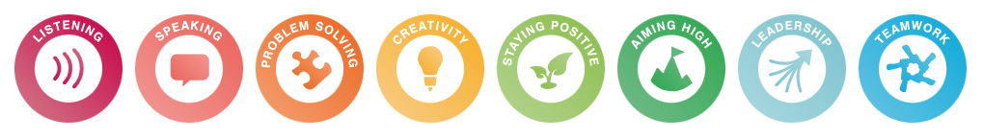

Fun Fair
KS3
Focus Subjects:
DT, PE

