Arts:
Art – Famous artists from around the world.
(NC) – Learn about great artists, architects & designers
LO: Pupils will explore the work of famous artists from around the world, developing awareness of different styles, techniques and cultural influences to inspire their own artwork.
DT – Models of famous landmarks
(NC) Use annotated sketches and prototypes to explain ideas. Evaluate existing products and improve own work
LO: Pupils will design and create models of famous landmarks, using simple materials and techniques to develop and communicate their ideas.
Music – Music from different cultures
(NC) Appreciate wide range of live & recorded music appreciate and understand a wide range of music drawn from different traditions
LO: Pupils will listen and respond to music from different cultures, developing awareness of rhythm, instruments and how music reflects traditions and ways of life.

Humanities:
Geog – Countries & landmarks around the world. (NC) Name & locate counties, cities, regions & features of UK . Understand latitude, longitude, Equator, hemispheres, tropics, polar circles & time zones
LO: Pupils will explore countries and landmarks around the world, developing awareness of where places are located and recognising key geographical features.
History – Historical sites around the world
(NC) Broader History Study • Non-European society, i.e. - Islamic civilization, including Baghdad - Mayan civilization - Benin (West Africa)
LO: Pupils will explore historical sites from around the world, developing awareness of different cultures and recognising that people lived differently in the past.
RE – Religion around the world (Equals)
2.4.5 What do the creation stories teach us?
2.6.1 How and why should we care for our world?
LO: Pupils will explore creation stories from different beliefs, developing awareness of how people explain the world and what these stories teach about values.

Computing –
(Teach Computing) Digital Literacy
LO: Pupils will use digital tools to explore and present information, developing skills in creating and organising digital content.

Personal Development:
Life skills –
Road safety
Food hygiene and prep - cooking foods from around the world
Keeping Safe Curriculum
LO: Pupils will develop awareness of road safety, recognising how to stay safe when near roads and understanding the importance of following simple safety rules.
PSHE: (PSHE Association Framework)
Self-care, safety & support – Keeping safe
The world I live in - Jobs people do /
Taking care of the environment /
Belonging to a community
LO: Pupils will develop awareness of how to keep themselves safe, recognising trusted adults and understanding how to seek help when needed.
RSE – Knowing my body, Body parts, Gender
Baby to adult
LO: Pupils will identify and name basic body parts, developing awareness of their own bodies and recognising simple similarities and differences.

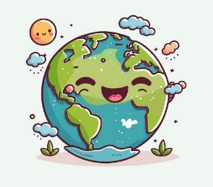
Science:
Earth & Space – Exploring space
the consequences of the relative movement between the Sun, the Moon and the Earth in the context of the Solar System.
LO: Pupils will explore the Earth, Moon and Sun, developing awareness of how their movements create day and night and affect life on Earth.
Forces
Physics - Understand location and interaction of Sun, Earth & Moon
Introduce gravity, resistance & mechanical forces
LO: Pupils will explore forces through practical activities, developing awareness of how pushes, pulls and gravity affect movement.

Physical Development:

PE - Athletics – Races
Competitive/Team games – The Olympics, World cup, Euros, Tennis NC Use running, jumping, catching and throwing in isolation and in combination
LO: Pupils will develop running skills by taking part in races, exploring speed, direction and coordination while responding to simple instructions and challenges.

Swimming
Sensory Kingdom
Sensory Circuit
What a Wonderful World

KS2

Maths:

Daily basic skills focusing on Number through the Little Big Maths approach

Geometry – Position & direction
Measure – Length / Money

PfA Skills Builder:
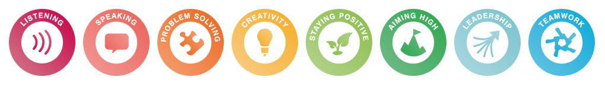

English:

Daily basic skills focusing on Read Write Inc Phonics and reading skill development

Texts:
Poetry – Around the world in eighty poems
Fiction – Meet the planets (Caryl Hart) The Boy who sailed the world (Julia Green)
Non-Fiction –Questions and Answers about our World- Usborne (Lift the flap).
Focus Subjects:
Humanities

