My Independence:

EQUALs Responsibility for environment

PSHE Association: Health & Wellbeing → Self-care & responsibility

LO: Pupils will take responsibility for simple environmental tasks.
NC: PSHE – Responsibility and community

My Sensory Play:

EQUALs Natural materials.

LO: Pupils will explore natural materials using their senses.
NC: Science – Properties of materials

My Communication:

EQUALs Expressing opinions

LO: Pupils will express preferences about their environment.
NC: English- Spoken Language

My Physical Well-Being:
EQUALs Outdoor physical tasks
LO: Pupils will develop coordination through outdoor tasks.
NC: PE

MOVE
Sensory Swimming
Sensory Kingdom
English:
Daily basic skills focusing on Read Write Inc Phonics and reading skill development
Texts:
Fiction – Turtle Bay
Poetry – Bless the Earth
Non-fiction – What a Waste
My Creativity:

EQUALs Recycled art

LO: Pupils will create using recycled materials.
NC: Art / Computing

RE:
EQUALs Unit 2.3.4 What can the Buddha teach us?

LO: Pupils will explore what the Buddha teaches about being kind, calm and respectful through stories, sensory activities and shared experiences.

NC: Understand that the Buddha is important in Buddhism and recognise some of his teachings (e.g. kindness, mindfulness, helping others)

My Outdoor School:
EQUALs Environmental exploration
LO: Pupils will explore and observe their local environment.
NC: Geography – Fieldwork and observation

Maths:
Daily basic skills focusing on Number through the Little Big Maths approach
Geometry/Measure - Time 1
PfA Skills Builder:
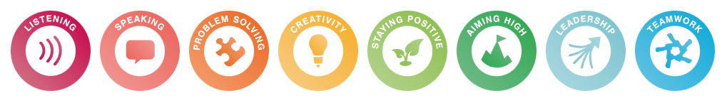

Conservation
KS2
Focus Subjects:
Geography, Science

