My Independence:

EQUALs Routine tasks

PSHE Association: Health & Wellbeing → Self-awareness

LO: Pupils will follow structured routines independently.
NC: PSHE

My Sensory Play:

EQUALs Fabrics and textures
LO: Pupils will explore different textures.
NC: Science

My Communication:

EQUALs Expressing ideas
LO: Pupils will communicate ideas through speech or AAC.
NC: English

My Physical Well-Being:
EQUALs Movement
LO: Pupils will develop coordination.
NC: PE

MOVE
Sensory Swimming
Sensory Kingdom
My Creativity:

EQUALs Costume and design
LO: Pupils will create themed designs.
NC: Art / Music

Maths:
Daily basic skills focusing on Number through the Little Big Maths approach
Geometry/Measure- EQUALs Time
PfA Skills Builder:
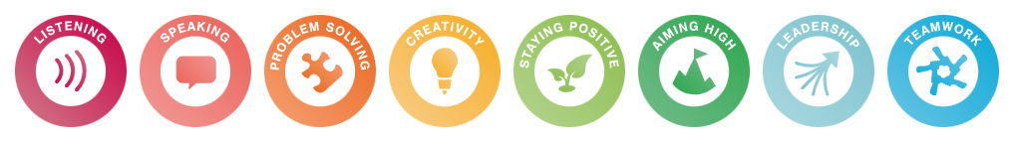

Kings and Queen
KS3
Focus Subjects:
History, Art

RE:

EQUALs 3.7.4 How do Muslims live their life through the Qur’an?

LO: Pupils will explore how the Qur’an guides Muslim daily life through stories, routines and shared experiences, developing awareness of how beliefs influence actions and choices.
NC: Understand that the Qur’an is the holy book of Islam and that Muslims use it as guidance for how to live their lives

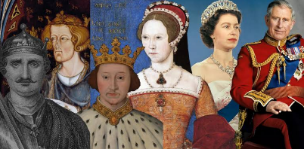
My Outdoor School:
EQUALs Grounds exploration
LO: Pupils will explore familiar outdoor spaces.
NC: Geography

English:
Daily basic skills focusing on Read Write Inc Phonics and reading skill development
Texts:
Fiction: The Kings Crown- Rose Cobden and Rosalind Maroney and Paddington at the palace- Michael Bond
Non- Fiction: Sing a song of six pence and Pussy Cat Pussy Cat
Poetry: British Kings and Queens- A ladybird book and Henry VIII: King of England 1509-1547- Ben Hubbard

