My Independence:

EQUALs Organising belongings for activities
PSHE Association: Health & Wellbeing → Self-care (recognising routines and needs)
LO: Pupils will begin to independently manage their belongings for familiar routines.
NC: PSHE – Developing independence and responsibility

My Sensory Play:

EQUALs Exploring textures and movement journeys
LO: Pupils will explore a range of sensory stimuli to support engagement and regulation.
NC: Science – Everyday materials (exploring properties)

My Communication:

EQUALs Requesting items and expressing choices
LO: Pupils will communicate needs and preferences using appropriate methods (AAC, gesture, speech).
NC: English – Spoken language (expressing ideas and needs)

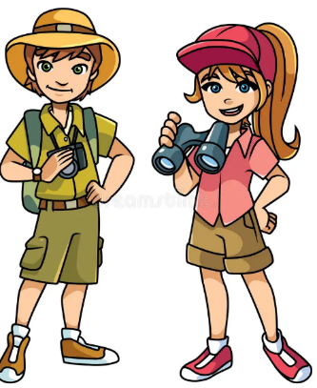
Maths:
Daily basic skills focusing on Number through the Little Big Maths approach
Geometry- EQUALs Reasoning about numbers or shapes
LO: Pupils will explore and reason about numbers and shapes by identifying, comparing, sorting and describing similarities and differences, developing their understanding of mathematical patterns and relationships.
NC: Identify and describe the properties of 2D and 3D shapes.
PfA Skills 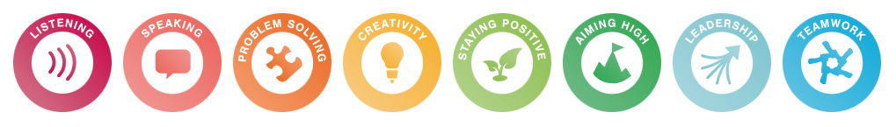Builder:

English:
Daily basic skills focusing on Read Write Inc Phonics and reading skill development
Texts:
Fiction:
Non- Fiction:
Poetry:
My Creativity:

EQUALs Map-making, role play adventures

LO: Pupils will represent ideas through creative and imaginative activities.

NC: Art & Design – Use a range of materials creatively

RE:

EQUALs Unit: 1.1.2 how is it celebrated?

LO: Pupils will explore how different people celebrate special events through sensory experiences, shared activities and familiar routines
NC: Understand how and why people celebrate special times and events

My Outdoor School:
EQUALs Exploring local environment and routes
LO: Pupils will explore and recognise features of their immediate environment.
NC: Geography – Use simple fieldwork and observational skills

My Physical Well-Being:
EQUALs Movement, balance and coordination
LO: Pupils will develop fundamental movement skills and coordination.
NC: PE – Master basic movements (balance, agility, coordination)

MOVE
Sensory Swimming
Sensory Kingdom
Let’s go on an adventure
KS1
Focus Subjects:
Geography, PE

