My Independence:

EQUALs Following routines

PSHE Association: Health & Wellbeing → Self-care (independence in responsibilities)

LO: Pupils will follow structured routines.
NC: PSHE

My Sensory Play:

EQUALs Water exploration
LO: Pupils will explore water through sensory play.
NC: Science

My Communication:

EQUALs Sharing experiences
LO: Pupils will communicate experiences with others.
NC: English

My Physical Well-Being:
EQUALs Movement/coordination
LO: Pupils will develop coordination through movement.
NC: PE

MOVE
Sensory Swimming
Sensory Kingdom
English:
Daily basic skills focusing on Read Write Inc Phonics and reading skill development
Texts:
Fiction:
Non- Fiction:
Poetry:
My Creativity:

EQUALs Ocean art

LO: Pupils will create representations of ocean life.
NC: Art / Computing

RE:
EQUALs Unit 2.3.6 What do people around me believe?

LO: Pupils will explore the different beliefs and traditions of people around them through shared experiences, stories and sensory activities, developing awareness that people think and believe different things.

NC: Understand that people have different beliefs, religions and ways of life, and recognise some similarities and differences

My Outdoor School:
EQUALs Water environments
LO: Pupils will explore outdoor water environments.
NC: Geography

Maths:
Daily basic skills focusing on Number through the Little Big Maths approach
Geometry/Measure- EQUALs Weight and Volume 2
PfA Skills Builder:
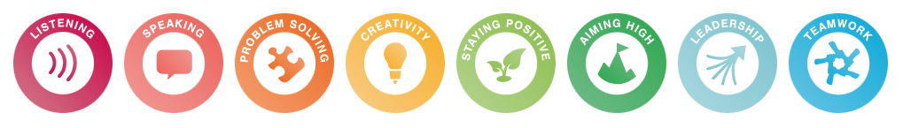

The ocean
KS2
Focus Subjects:
Geography, Science

