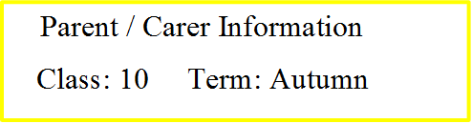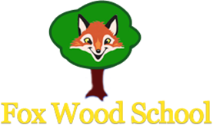

**Class snack money is £1.50 per week.**

Although we cannot go on any educational visits through the autumn term we will still be doing all we can to explore as much of our local community as we can! We will regularly be visiting the backfield, the green mile and around the immediate school area when exploring what nature the school has to offer. We may also venture to the forest schools area to play our natural musical instruments. We will also exploring other areas of the school, such as the sensory kingdom, for a variety of different subjects such as PE, life skills and arts. The use of photos and media will allow us to experience the local community and what it has to offer.

During arts, class 10 will be exploring a variety of artists and comparing and describing artists work using symbols and communication devices. Pupils will have the opportunity to explore the outdoors and collect a variety of items for their individual nature art pieces. Pupils will evaluate and describe their work using symbols. Once pupils have completed their nature art, they will collaborate them together to create a class piece! Pupils will also be using the outdoors to create musical instruments using natural resources; they will then explore their work in a campfire-like environment!

In maths, we are developing our number skills through counting, recognition and problem solving. In topic Maths, we are developing our knowledge of 3D shapes, exploring and investigating capacity and applying maths skills to everyday life such as cookery, enterprise, money, shape and sequencing daily events. This term’s Maths will involve lots of socialising with our class peers with emphasis on sharing, songs and rhymes and class discussions through a variety of sensory, functional and problem solving activities.

In literacy, we will be focusing on developing our speaking and listening skills, specifically on listening to a variety of animal sounds and letter sounds. We will be developing our writing skills using a variety of media and materials. For our reading focus, we will be exploring various different poems as well as the story ‘In It Together’. We will be reading daily each morning in class, it would be great if you could support your child at home by sharing a book with them and filling in the relevant box to explain how your child is reading at home!

Our theme this half term is: “Local Community”. It is all about exploring our local community and comparing it to other places around the world. We will be identifying different locations and buildings and suggesting reasons why they are important in our community. We will be exploring maps of familiar locations and using bee-bots to travel from one area to another. We will also be developing our knowledge of landmarks and even creating our own Fox Wood landmark!