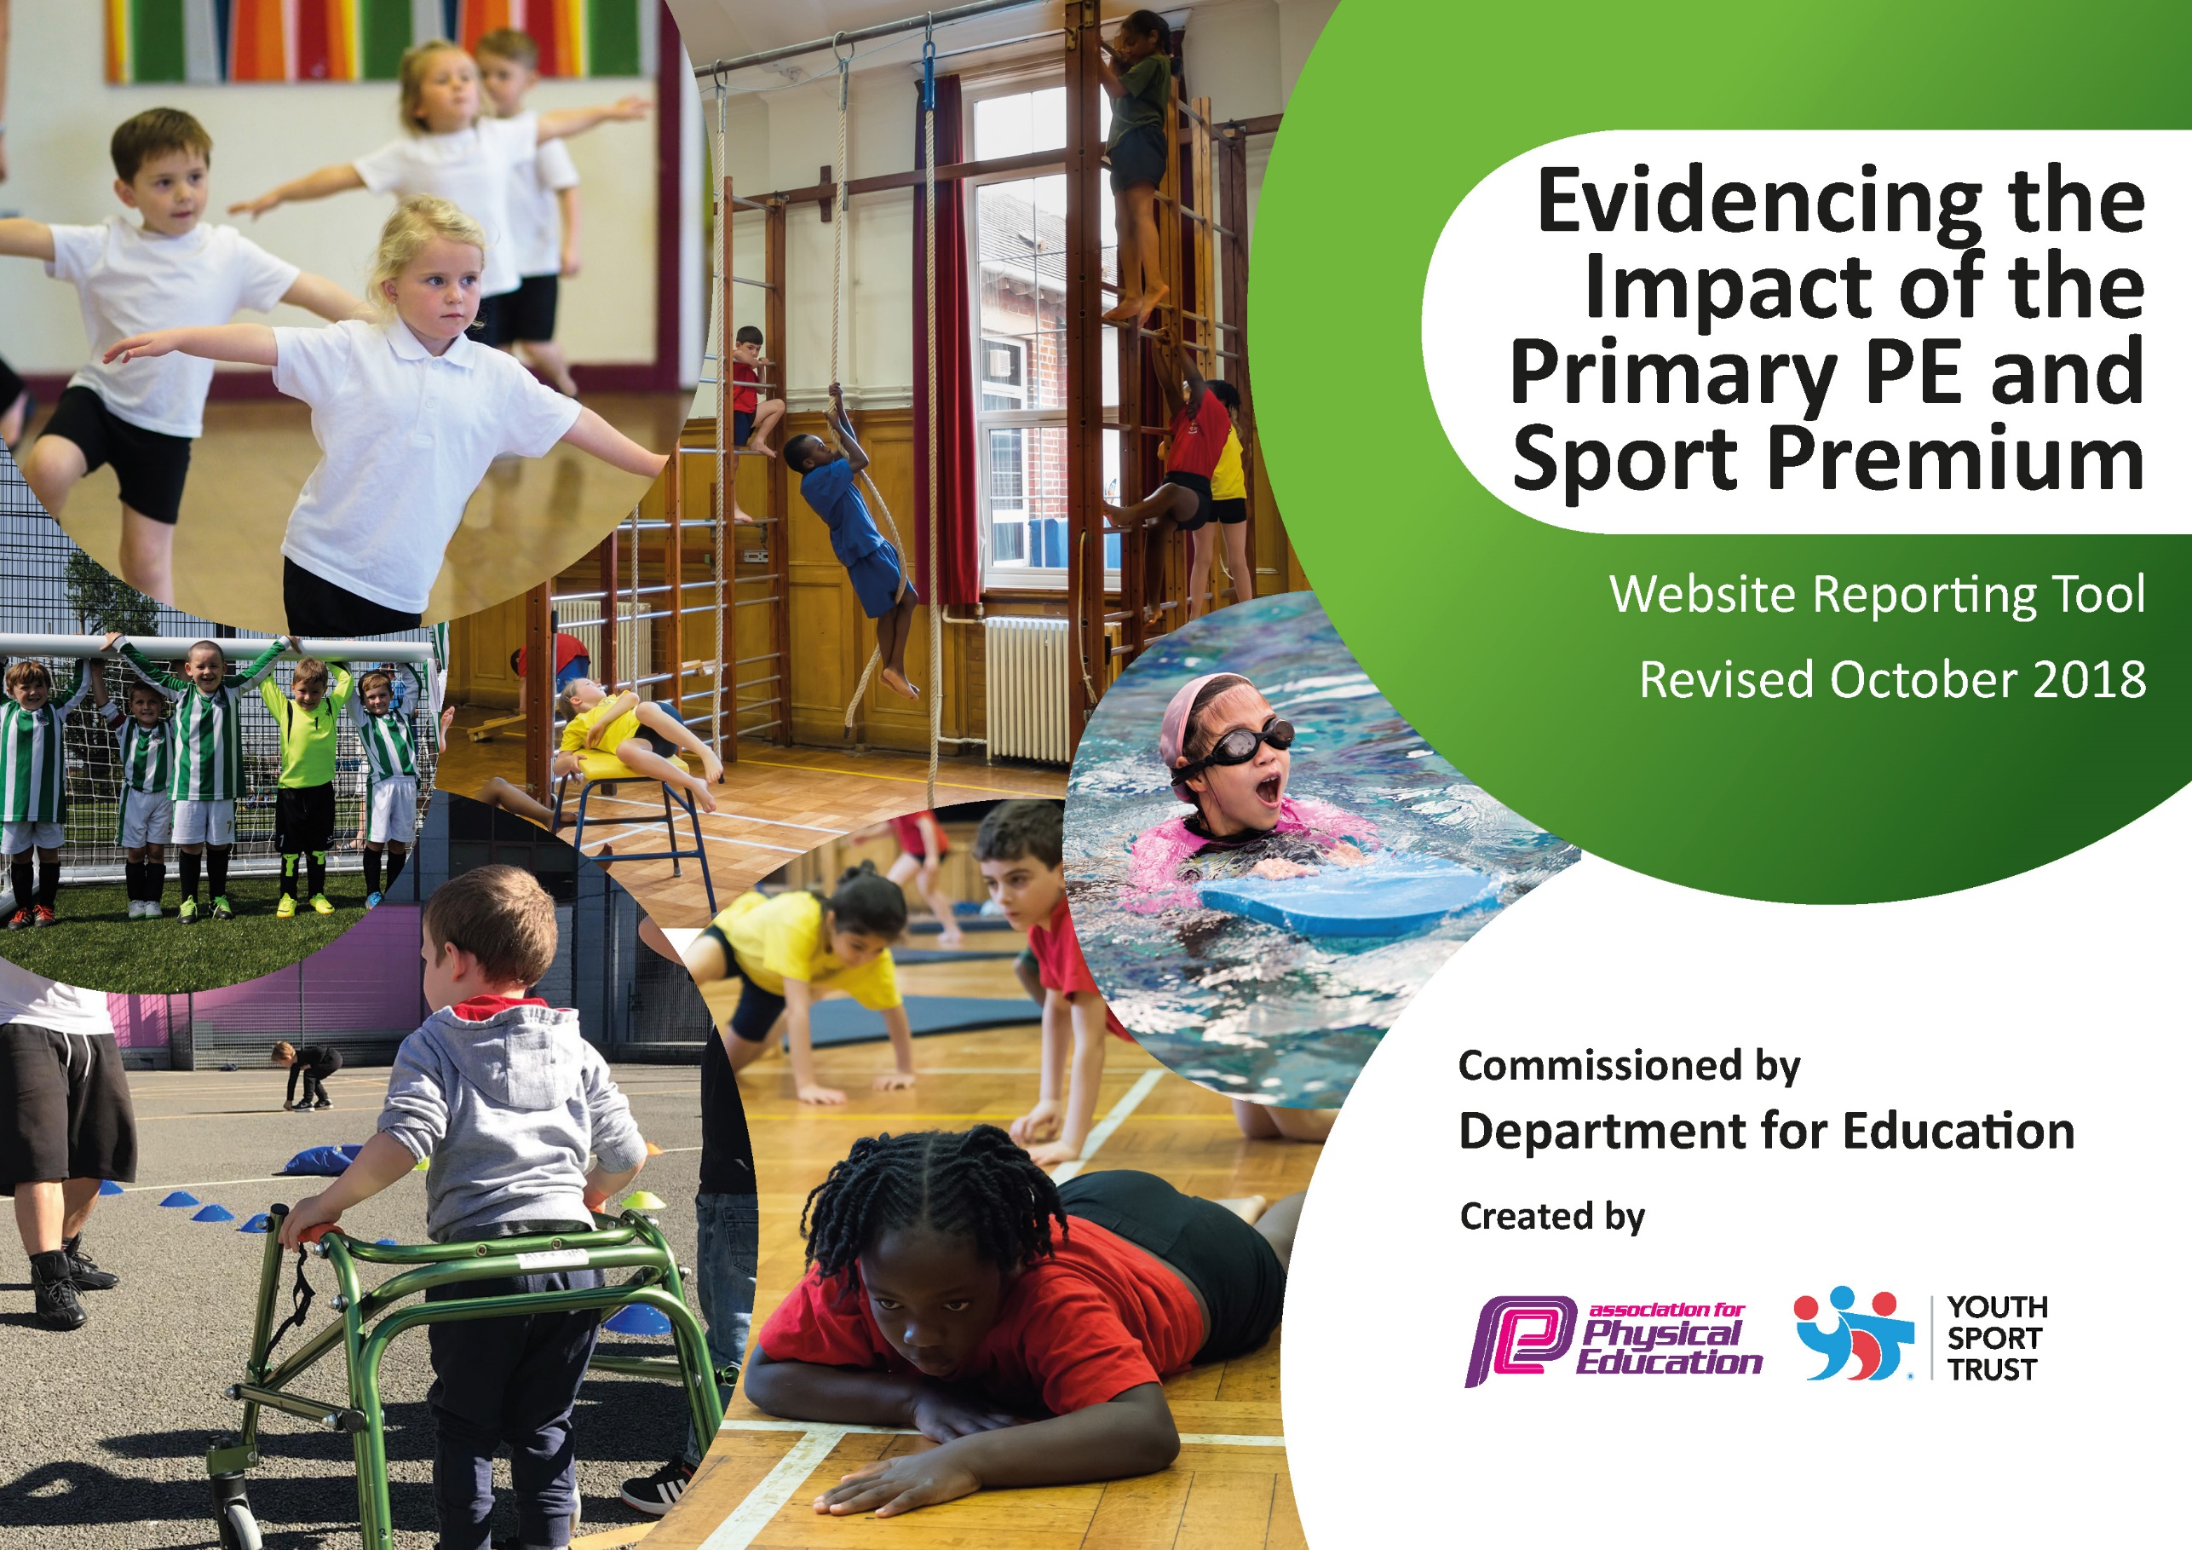
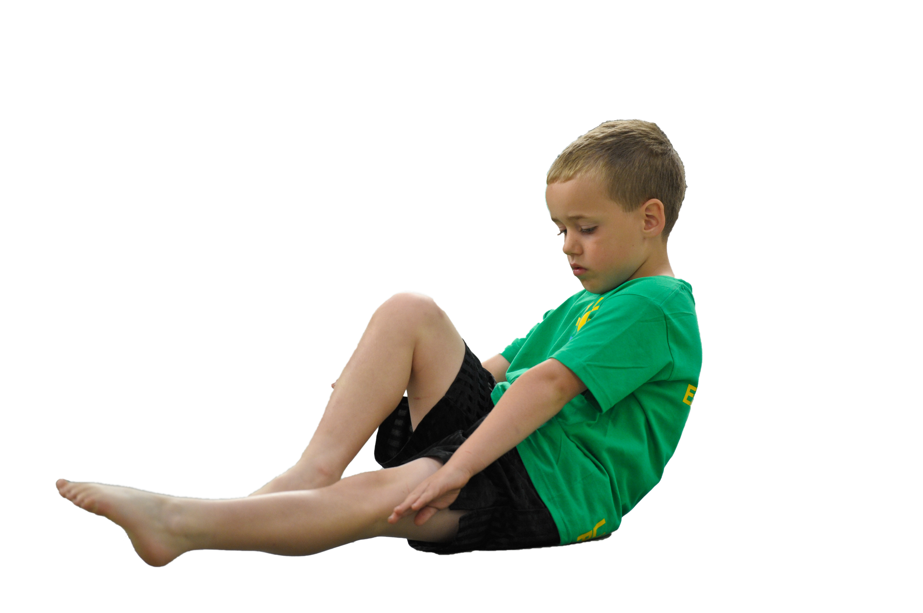
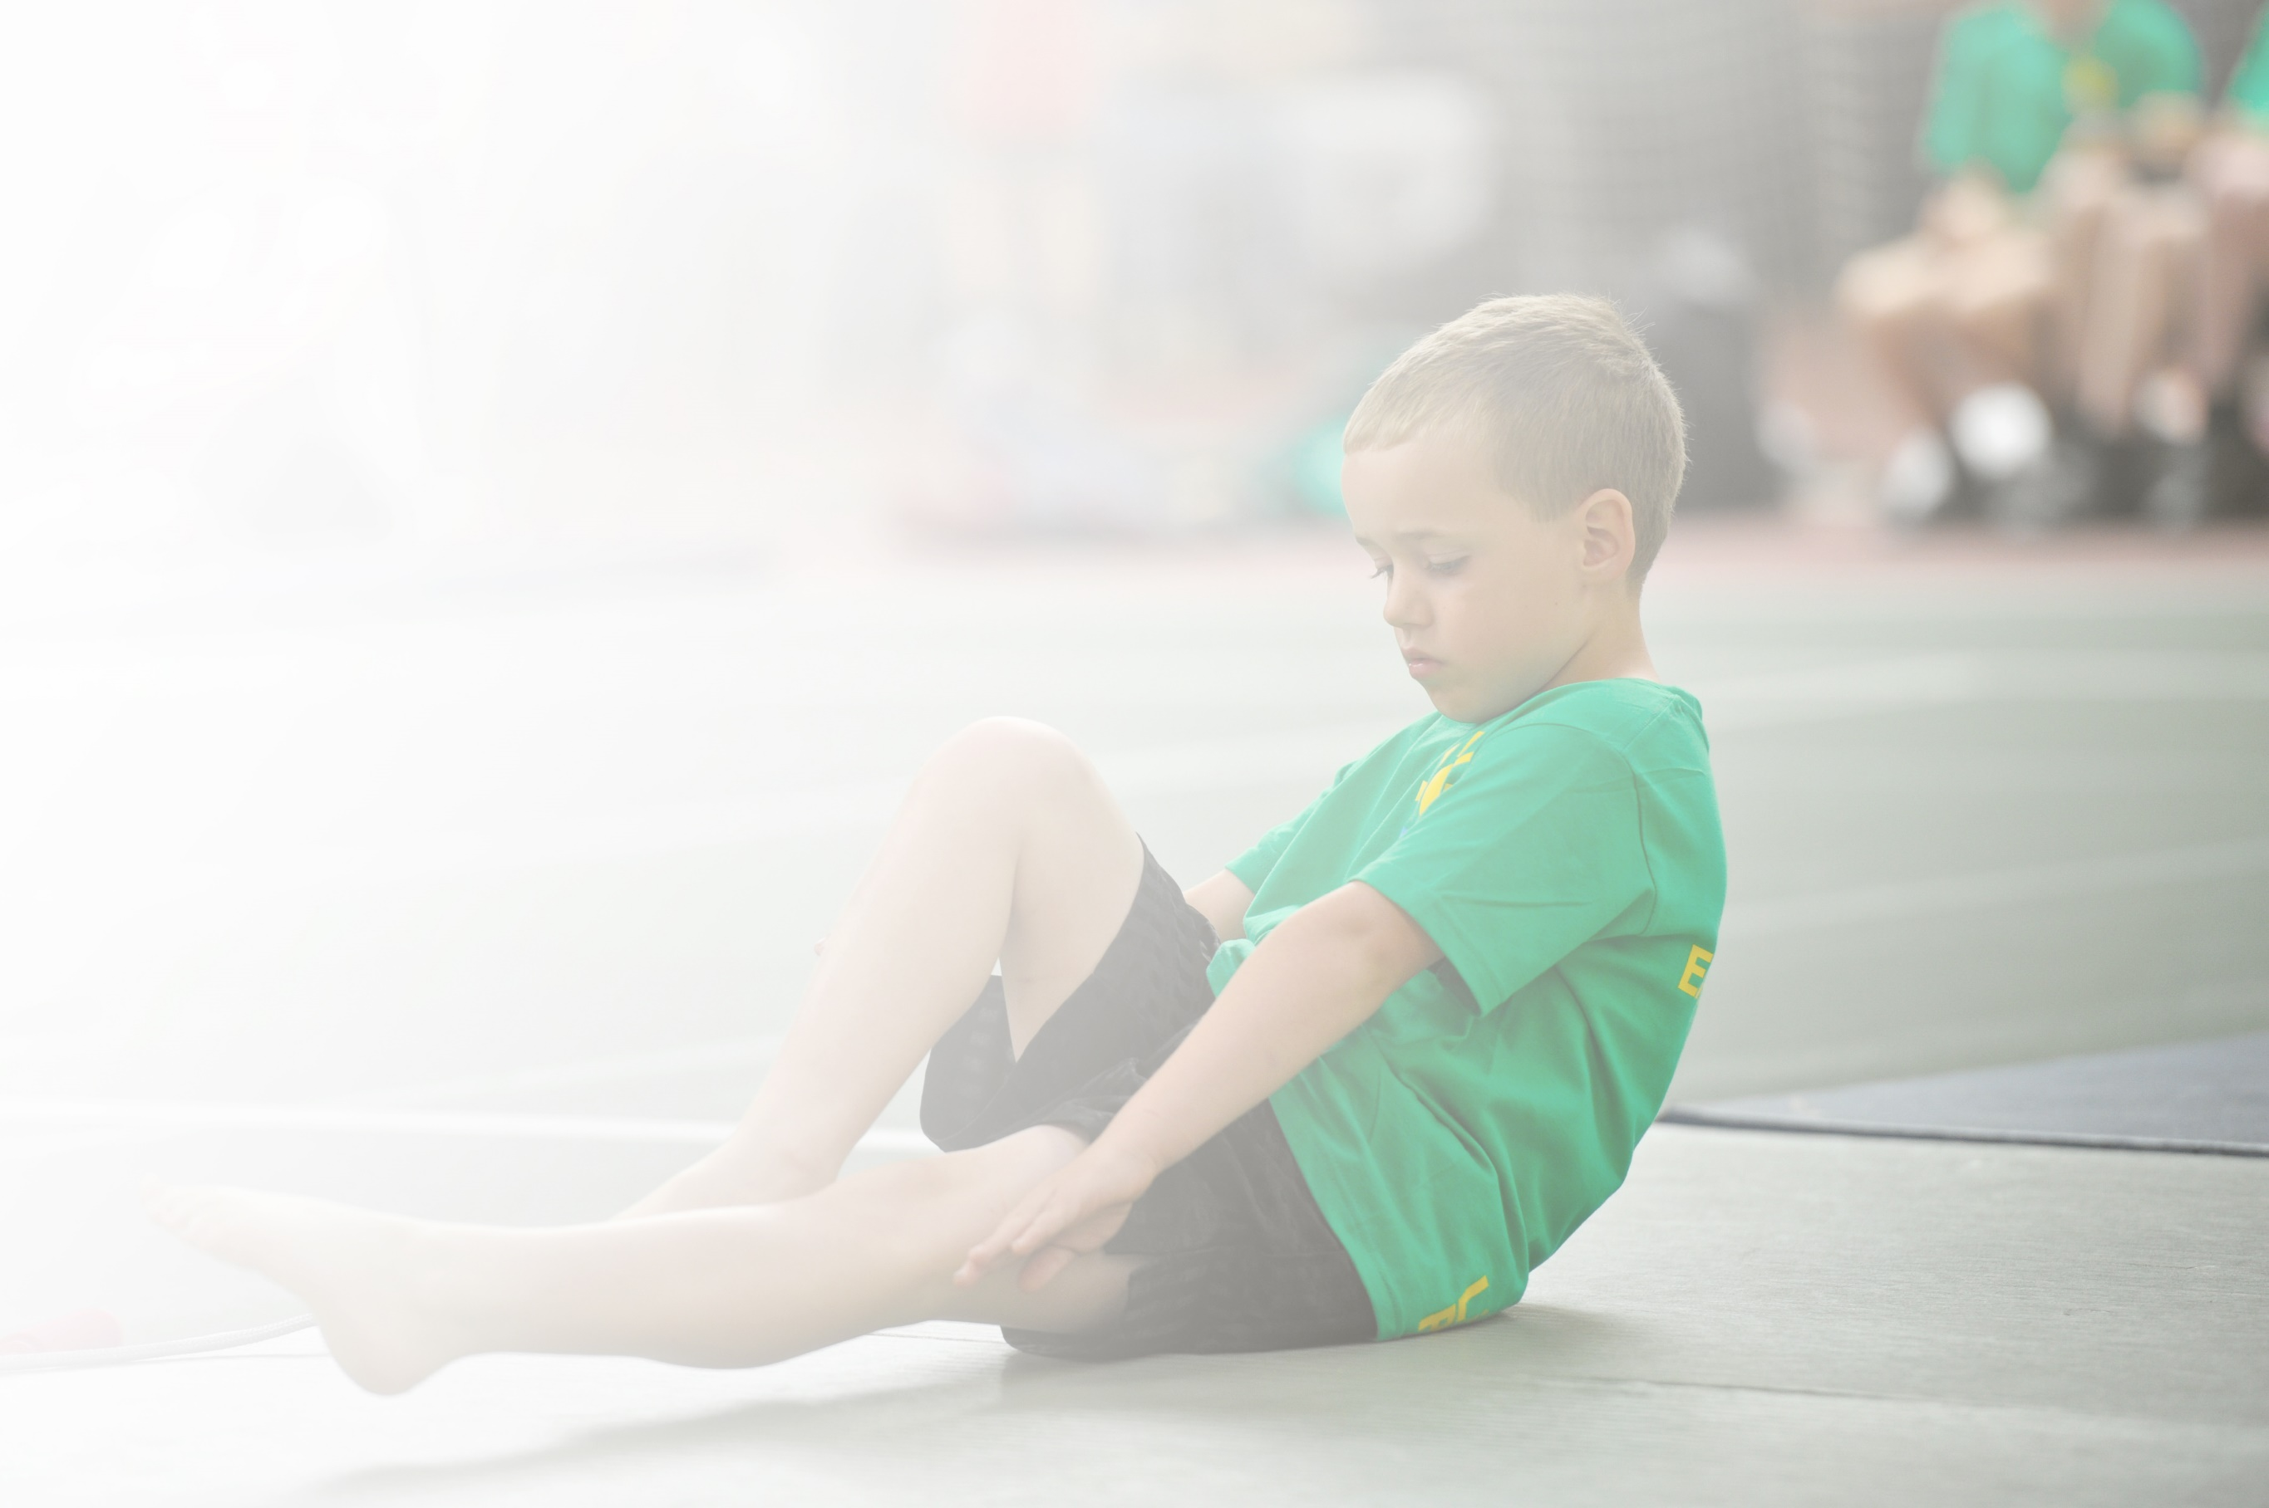
Schools must use the funding to make additional and sustainable improvements to the quality of Physical Education, Sport and Physical Activity (PESPA) they offer. This means that you should use the Primary PE and Sport Premium to:

- Develop or add to the PESPA activities that your school already offer
- Build capacity and capability within the school to ensure that improvements made now will benefit pupils joining the school in future years

Please visit gov.uk for the revised DfE guidance including the 5 key indicators across which schools should demonstrate an improvement. This document will help you to review your provision and to report
your spend. DfE encourages schools to use this template as an effective way of meeting the reporting requirements of the Primary PE and Sport Premium.

We recommend you start by reflecting on the impact of current provision and reviewing the previous
spend. Under the Ofsted Schools Inspection Framework, inspectors will assess how effectively leaders use the Primary PE and Sport Premium and measure its impact on outcomes for pupils, and how effectively governors hold them to account for this.

Schools are required to publish details of how they spend this funding as well as on the impact it has on pupils’ PE and sport participation and attainment by the end of the summer term or by 31 July 2019 at the
latest.
We recommend regularly updating the table and publishing it
on your website throughout the year, as evidence of your
ongoing review into how you are using the money to
secure maximum, sustainable impact. To see an
example of how to complete the table please
click HERE.

Support for review and reflection - considering the 5 key indicators from DfE, what development needs are a priority for your setting and your students now and why? Use the space below to reflect on previous spend, identify current need and priorities for the future.

Key achievements to date: | Areas for further improvement and baseline evidence of need:
- Sensory kingdom is now fully equipped to meet the need of all our pupils accessing sensory/physical regulation activities.  - PE SLA with Warrington has been successful. | - Develop staff knowledge, confidence and skills of PE and sports delivery across school.  - Encourage pupil participation in competitions/games with other schools.  - Develop the SLA with Warrington/Livewire to ensure we have a correct package of delivery to suit all our pupils needs.  - Ensure the delivery of our physical activities is sustainable ensuring we have onsite training opportunities available.

Meeting national curriculum requirements for swimming and water safety | Please complete all of the below:
What percentage of your current Year 6 cohort swim competently, confidently and proficiently over a distance of at least 25 metres?  N.B. Even though your children may swim in another year please report on their attainment on leaving  primary school. | 0 %
What percentage of your current Year 6 cohort use a range of strokes effectively [for example, front crawl, backstroke and breaststroke]? | 0 %
What percentage of your current Year 6 cohort perform safe self-rescue in different water-based situations? | 0 %
Schools can choose to use the Primary PE and Sport Premium to provide additional provision for swimming but this must be for activity over and above the national curriculum requirements. Have you used it in this way? | Yes

Action Plan and Budget Tracking
Capture your intended annual spend against the 5 key indicators. Clarify the success criteria and evidence of impact that you intend to measure to evaluate for students today and for the future.

Academic Year: September 2018- August 2019 | Total fund allocated: £ 17,512 | Date Updated: July 19
Key indicator 1: The engagement of all pupils in regular physical activity – Chief Medical Officer guidelines recommend that primary school children undertake at least 30 minutes of physical activity a day in school |  |  |  | Percentage of total allocation:
 |  |  |  | 2%
School focus with clarity on intended impact on pupils: | Actions to achieve: | Funding allocated: | Evidence and impact: | Sustainability and suggested next steps:
- Subject leader to research and evaluate current practice across school. Looking at the opportunities our pupils have to access 30 minutes of physical activity daily. Evaluating this should lead the SL into devising a method of delivery so that all pupils have the opportunity.  - Provide more opportunity for PMLD pupils to have access to movement and physio programmes daily | - Complete a school survey and report findings to SLT to highlight any areas that need further support to develop physical activity each day.  - Ensure that all pupils are accessing regular physical activity each day. | £400.00 | - Timetables should show all pupils have access to at least 30 minutes of physical activity per day. Where gaps are highlighted SL to work alongside Teachers to be creative with learning and increase opportunities. | - This monitoring activity should be completed by the SL once per term to ensure timetables reflect the required practice.
Key indicator 2: The profile of PESSPA being raised across the school as a tool for whole school improvement |  |  |  | Percentage of total allocation:
 |  |  |  | 15%
School focus with clarity on intended impact on pupils: | Actions to achieve: | Funding allocated: | Evidence and impact: | Sustainability and suggested next steps:
- Subject leader to attend training in hydrotherapy/swimming and rebound therapy in order to up-skill their own knowledge and understanding so they can confidently disseminate to all staff, thus increasing their knowledge and confidence. | - Enrolled in the relevant courses and cover provided as required.  - Liaised with SLT to ensure staff meeting time was allocated in order to disseminate to staff.  - Provided cover so subjects lead could team teach/observe all members of staff at least once. Share experience knowledge and skills whole school. | £1600 | - Increased confidence, self-esteem and a real desire to learn. The enjoyment of PE increased participation in wider activities  - Development of co-operation/working in groups/desire to learn impacted right across the whole curriculum and standards improved significantly | - SL to provide regular drop in clinics for staff to request support/ guidance.

Key indicator 3: Increased confidence, knowledge and skills of all staff in teaching PE and sport |  |  |  | Percentage of total allocation:
 |  |  |  | 22%
School focus with clarity on intended  impact on pupils: | Actions to achieve: | Funding  allocated: | Evidence and impact: | Sustainability and suggested  next steps:
- Subject Leader and 2 further teachers to undertake real PE training (February - May) in order to up-skill their own knowledge and understanding so they can confidently disseminate to all staff, thus increasing their knowledge and confidence.  - Implement the use of My Therapy tracker with our pupils to track the physical progress of the OT therapy input.  - Maintain the Warrington service level agreement for PE and sports | - Enrolled in the locally delivered real PE courses and cover provided as required.  - Liaised with SLT to ensure staff meeting time was allocated in order to disseminate to staff.  - Provided cover so subjects lead could team teach/observe all members of staff at least once. Share experience knowledge and skills whole school.  - Develop the PE curriculum based on the outcomes of the training provided. | £4000 | - Increased confidence, self-esteem and a real desire to learn. The enjoyment of PE increased participation in wider activities  - Development of co-operation/working in groups/desire to learn impacted right across the whole curriculum and standards improved significantly | - The subject leader will use time within staff meeting time once per month; together with slots in professional development days to ensure all staff are kept up to date and that new staff are brought up to speed.
Key indicator 4: Broader experience of a range of sports and activities offered to all pupils |  |  |  | Percentage of total allocation:
 |  |  |  | 43%
School focus with clarity on intended  impact on pupils: | Actions to achieve: | Funding  allocated: | Evidence and impact: | Sustainability and suggested  next steps:
- Subject leader to get a solid understanding of sports delivery across school from long, medium and short term planning. Evaluate the breath of experiences the pupils have and devise an action plan to introduce a wider range of sports to school.  - Wolves foundation to provide increased range of opportunities for our pupils to access sporting activities. This will increase the subject knowledge and confidence of teachers and teaching assistants throughout the school in supporting such activities.  - Provide opportunities for pupils to access an appropriate community swim session.  - Provide opportunity for pupils to access an appropriate community sporting event.  - Pupils to access wheels4all activity facility in the local community. | - Devise and distribute a pupil and staff questionnaire to highlight areas for development, interests and resource implications.  - Work with the PE team to have a robust PE stock/equipment audit. To then use the information from the questionnaire to look at the options to add a wide range of equipment.  - Pupils from non-community swimming classes to access the community swim facilities and teaching sessions.  - Pupils to attend externally organised sporting events within the local and wider community.  - Pupils to explore and experience a wider range of physical exercise activities. | £7540 | - Increased confidence, self-esteem and a real desire to learn. The enjoyment of PE increased participation in wider activities  - Teachers have the tools and knowledge to be creative with their curriculum planning.  - Pupil’s engagement and levels of fun increase with an increased range of equipment. | - This monitoring activity should be completed by the SL once per term to ensure timetables reflect the required practice
Key indicator 5: Increased participation in competitive sport |  |  |  | Percentage of total allocation:
 |  |  |  | 8%
School focus with clarity on intended  impact on pupils: | Actions to achieve: | Funding  allocated: | Evidence and impact: | Sustainability and suggested  next steps:
- Subject leader to liaise and engage with our special schools PE lead to develop links to sports in the wider community giving our pupils opportunity to access off site sporting activities. Encouraging other schools to link with us allowing us to host sporting activities in our school during the summer term.  - Pupils to participate in a competitive sensory trail in the local park promoting resilience, enjoyment, competition. | - Access off site competitive games  - Introduce the onsite sporting challenges  - Plan and organise a competitive sensory trail for all pupils. | £1500 | - Increased confidence, self- esteem and a real desire to learn. The enjoyment of PE increased participation in wider activities.  - Pupils get a feel and desire for competition developing there competitive side.  - Pupil’s engagement and levels of fun increase with an increased range of opportunities. | - Maintain relationship with special school PE lead and network with other schools whilst at events.

