TacPac 2

Tacpac draws together touch and music to create a structured half hour of sensory communication between two people.

Below is a link to a tacpac session to be used as a guide

https://www.youtube.com/watch?v=6xBhMd20vyE

Use the following link to stimulating music to learn too

https://www.youtube.com/watch?v=CB_PZSnen5A

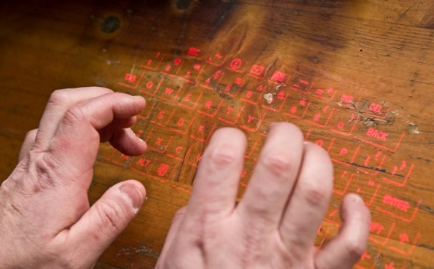
Tap

-In rhythm

-Pause

-Then rapid cascade

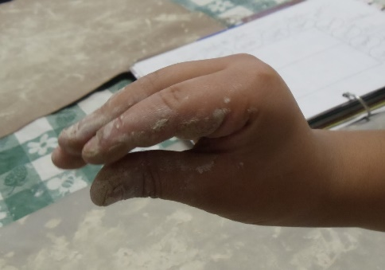
Snatch lightly

With soft, flat fingers, pulling away quickly and firmly

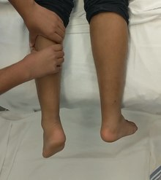
Squeeze

Firmly in sequence.

Draw

Draw squares and circles on skin

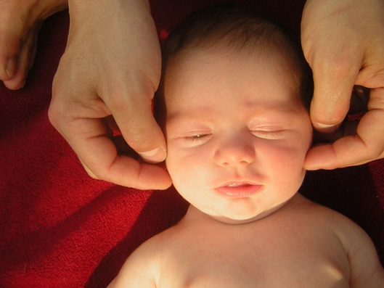
Massage

With finger tips

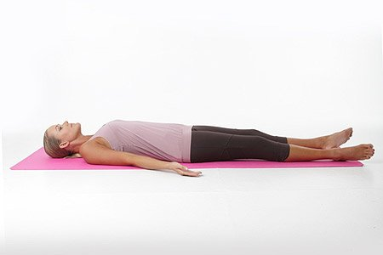
Relax

Keep in contact and listen

