TacPac 5

Tacpac draws together touch and music to create a structured half hour of sensory communication between two people.

Below is a link to a tacpac session to be used as a guide

https://www.youtube.com/watch?v=6xBhMd20vyE

Use the following link to stimulating music to learn too

https://www.youtube.com/watch?v=CB_PZSnen5A

Press and scrunch

(using wrapping paper/newspaper/tinfoil)

Press and scrunch onto hands arms and legs

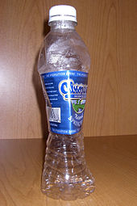
Puff

puff air with squeezy bottle on hands, arms, face, legs

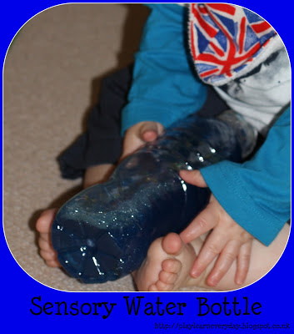
Rock and tip

Rock and tip water bottle on body

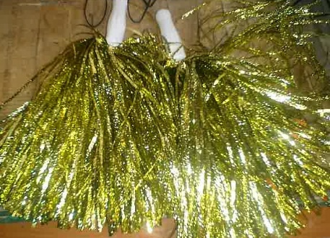
Drop and jostle

Drop and jostle pompom onto skin

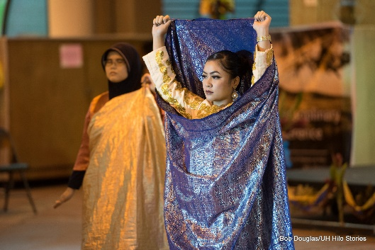

Lift and lower

Lift and lower arms and legs with scarf

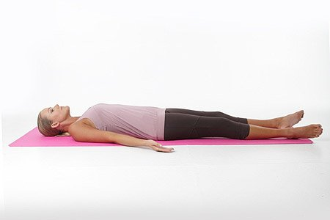
Relax

Keep in contact and listen

