Winter Sensory Bin ideas…

- Cotton balls
- Winter themed foam stickers (you can also print out or draw pictures to use)
- Scoop scissors or spoons

- Peppermint essence
- Bubble bath
- Snowflakes/ tinsel strands
- Kitchen utensils

- White rice
- Blue dyed rice
- Battery operated candles
- Containers
- Scoops
- Ice cube tray
- Christmas themed figures

- scented playdough- coconut, peppermint or cinnamon
- Rice
- Glitter
- pompoms
- Winter themed figures- trees, penguins, bears, snowmen

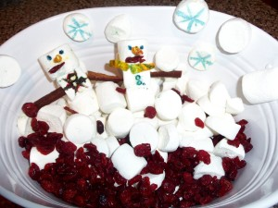

- Marshmallows
- Raisins or dried cranberries
- Twiglets
- Icing pens
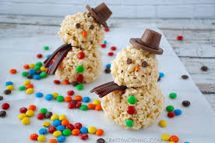

- Rice crispies
- Rice crispies with melted marshmallows
- Smarties or m&m’s
- Chocolate chips
- Chocolate buttons
- Rolo’s

