Fox Wood School

Colour, Smell and Texture of the Day

At Fox Wood School and sixth form college we have an agreed colour, smell and texture of the day that all pupils are introduced to on entry to school in Reception, or the year they join us in their academic journey.

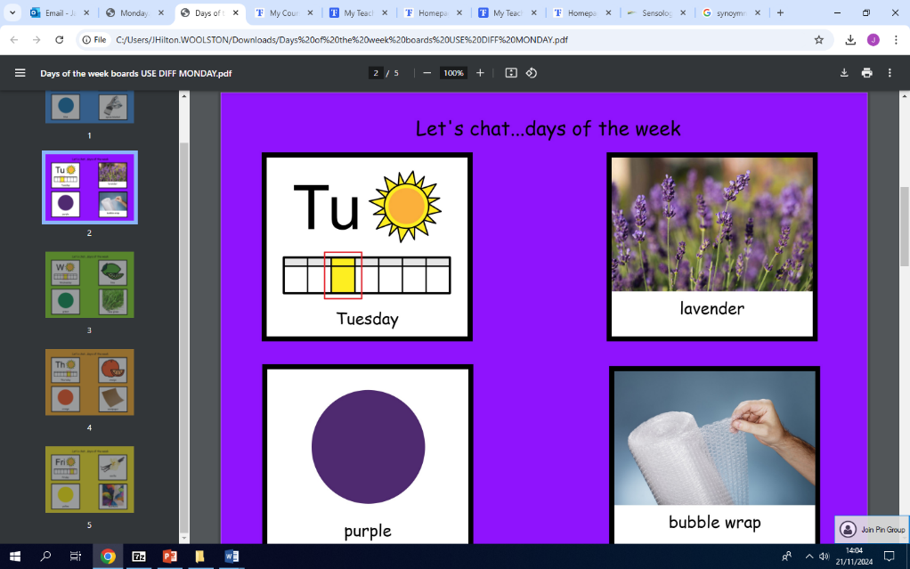Monday- Blue/ Peppermint/ Space Blankets

Tuesday- Purple/ Lavender/ Bubble Wrap

Wednesday- Green/ Lime/ Fake Grass

Thursday- Orange/ Orange/ Sandpaper

Friday- Yellow/ Vanilla/ Feathers

Every morning, each class of pupils are exposed to the smell of the day from safe scent jars, the colour of the day from a range of coloured symbols/ pictures/ objects to look at and explore and the texture of the day to explore through touch, as part of our morning introduction.

Each class has their own bespoke routine/ system that is appropriate to their learners, but the smells, textures and colours remain consistent throughout school. Sometimes the routine is adult led or guided and in other classes, the pupils are encouraged to take a more independent role in their own learning by organising the resources; setting out and ordering the objects, symbols etc.

Each class have their own chat board/ symbol board or strips depending on the cognitive abilities of the learners and these are used consistently in conjunction with the daily routine.

Many of our pupils have PMLD (profound and multiple learning disabilities with complex sensory and or medical needs and impairments.)

We use Sensology during Ready to Learn to introduce the days of the week for our very sensory learners.

Sensology’s aims are to wake up the five basic senses (see, hear, touch, smell, taste) and also movement related sensory systems: the vestibular (balance, head movements and gravity) and the proprioceptive (body positions, body mapping and planning movements).

Alongside the colour and smell of the day, we follow a routine to wake up each sense and cue the pupils into the current day so that they can better process/ make connections with what is happening and what will come next.

In addition to the daily routine that happens in all classes, in the Sensology sessions we have a specific song for each day as an audio cue and lip balms for pupils to experience the smell of the day through their sense of taste.

This is a lovely, fun and interactive start to the day and ensures that pupils’ senses are regulated and that they are ready to learn.