**Personal Development:**

Life skills – *‘My thinking and problem solving’-* Recognizing that before working on any activity, I need……

Keeping safe curriculum – My feelings sad, happy, puppet role play/ role play, building trust.

PSHE Association –

**Area of Focus:** Managing Feelings (AUT 1).

**Area of Focus:** Self-Awareness (AUT 2)

RSE – Knowing me. Different types of relationships

**Arts/DT:**

Art:

EQUALS : TEXTILES - Weaving, texture and pattern, further textiles and pattern.

PAINTING– Colour, tone and pattern, colour exploration.

NC - Use sketchbooks to collect, record, review, revisit & evaluate ideas

Music- Exploring, Collaborating, Creating, Performing, Listening – Body Percussion

RE- EQUALS UNIT 1.2.1 Why do some people say thank you at Harvest?

2.4.5 What do the creation stories teach us?

**Humanities:**

Geography – EQUALS: 2.7 Water, Water everywhere

NC – Name & locate counties, cities, regions & features of UK human geography, including types of settlement and land use, economic activity including trade links, and the distribution of natural resources including energy, food, minerals and water

History – Victorian Britain 2.11 – Pupils at work and school. NC – British history – an extended period study

Computing:

Computer Science: Introduction to Scratch Jnr: Teach Computing Curriculum. E-Safety: Managing Online Behaviour: navigating a simple webpage to get information I need

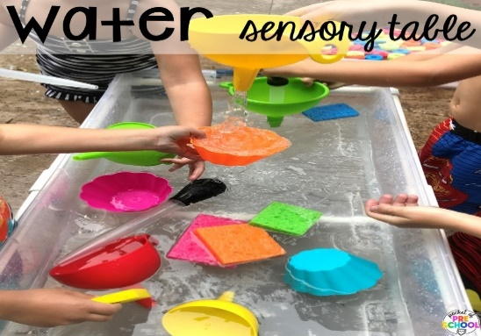

**Focus Subjects:**

Arts

**Maths:**

Daily basic skills focusing on Number through the Little Big Math’s approach

Geometry – Position and direction

Measure – Data and statistics

PfA Skills Builder:

**Physical Development**

Sensory Kingdom

PE – EQUALS - Invasion Games – Making your Mark

NC - play competitive games, modified where appropriate, and apply basic principles suitable for attacking and defending

**English:**

Daily basic skills focusing on Read Write Inc Phonics and reading skill development

Texts:

Fiction: Gruffalo/Room on a broom - Julia Donaldson

Non-Fiction: The Usborne outdoor book by Alice James and Emily Bone

Poetry: Poems to perform by Julia Donaldson

**Science:**

EQUALS - Everyday materials 1

NC - compare and group together everyday materials on the basis of their properties.

**ECO** - Global Citizenship

**Autumn –** Sensory Explosion

PINK KS2/3 AUTUMN