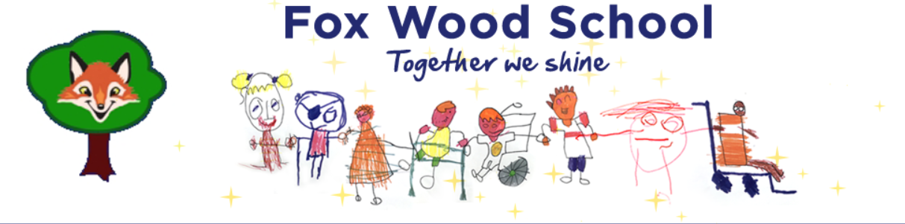

Fox Wood School Early Years Foundation Stage (EYFS)

Nutrition Guidance
This guide has been written in response to the document Early Years Foundation Stage Nutritional Guidance 2025. This document ensures that all children in our special school setting receive healthy, balanced, and individualised nutrition, aligned with EYFS statutory requirements. It addresses additional needs including ARFID, food allergies, religious/cultural dietary preferences, and gastrostomy feeding. The guiding principle is: A fed child is a happy child.
Guidance Purpose
- Ensure healthy, balanced, and individualised nutrition.
- Support ARFID, allergies, religious preferences, and gastrostomy feeding (pump, bolus, blended diet).
- Promote well-being through the principle: 'A fed child is a happy child.'

Policy Principles
- All meals/snacks follow EYFS nutritional guidance where possible healthy options are encouraged. It is recognised that pupils often have ARFID and eating issues around textures, tastes, smells, or other feeding differences. These differences can be severe and impact on the pupil’s diet. In these cases, pupils will be encouraged to try a ‘taste’ of different foods provided by the school kitchen – a small amount of each component. Pupils will be encouraged to touch, smell, roll on lips and taste these foods. Pupils will never be forced to eat food that they do not wish to and will always be offered preferred food choices once they have explored the food offered. Pupils may push the food away and this is ok. The food will continue to be offered and interaction with the less- preferred foods will be supported by staff.
- Children are never forced to finish food.
- Individual needs of pupils are respected these include medical, sensory, cultural, and religious needs.
- Staff foster strong relationships with parents. Feeding issues are often a cause of anxiety within the home, especially if a child has a narrow diet, or does not eat.
- Collaboration with families is vitally important. Before children start school staff liaise with parents to discuss how and what the child eats. Some children have limited foods that they will eat and on these occasions, the child will bring in a packed lunch from home and pupils have a taste of a school dinner, this allows the child to have familiarity in the food they are eating while still offering less-preferred foods.
- Some pupils will have a feeding plan and this will be adhered to – staff will be trained by Speech and Language therapists or the school community nursing team depending on the need of the pupil. It is important that the feeding plan is adhered to. Staff receive direction from the school nursing team and SaLT when pupils have a feeding plan and cannot deviate from the plan without permission from these professionals. Parents are encouraged to discuss alterations with these professionals in the first instance.

Menu Planning & Nutritional Standards
- Weekly menus include the four food groups: fruit & vegetables, starchy carbohydrates, dairy/alternatives, protein. These are provided by St Stephen’s Catholic Primary School kitchen and brought over to Fox Cubs.
- Portions are age-appropriate
- High salt, sugar, saturated fat, and choking hazards are avoided.
- Menu items are shared with families including allergens and substitutions.

Individual Feeding Plans
- Some pupils may have individual feeding plans, written by professionals involved in their care.
- These may include gastrostomy feeding pumps, blended diets, and mashing/ pureeing of foods.
- Staff will completely adhere to these and follow advice from the school nursing team (gastrostomy feeding) or Speech and Language Therapists.
- Staff will complete training in medical documentation, feeding methods, emergency protocols, environment adaptations and completing required paperwork as required. Training will be provided by the school nursing team (gastrostomy feeding) or the Speech and Language Team. Policies and procedures will be adhered to.
- Regular communication and review with families and professionals.

Specific Considerations
- ARFID: gradual exposure, sensory accommodations, avoid pressure.
- Allergies: collect action plans, prevent cross-contamination, label allergens clearly. Epi pens/ medications to be stored correctly. Staff to receive training.
- Religious preferences: respect halal, kosher, vegetarian, fasting needs.
- Gastrostomy feeding: document formula/blended diet, pump/bolus schedules, hygiene, escalation procedures.

Mealtime Practice & Training
- Meal times will be supportive and social with positive reinforcement.
- Staff will have training in EYFS nutrition, allergy management, ARFID, and G-tube feeding (as required). Staff will receive paediatric first aid (PFA) training and staff who are trained in PFA will be present when children are eating. Staff will sit facing the children
- All staff are aware of children’s plans and emergency procedures.

Monitoring, Review & Communication
- Policy and feeding plans reviewed with professionals and parents as needed.
- Families involved in updates encourage home-school dialogue.
- Maintain incident logs for allergic reactions, feeding issues, refusals.

Emergency & Health Procedures
- Follow protocols for anaphylaxis (EpiPen, call 999, notify parents).
- Gastrostomy tube emergencies referred to medical professionals immediately (see individual flow chart)
- Seizure management – follow individual seizure management plans.

