Fox Wood School Prospectus

Headteacher: Lucinda Duffy

Deputy Head Teacher: Lianne Buchanan

The Chair of Governors may be contacted through school

Fox Wood School

Woolston Learning Village

Holes Lane

Woolston

Warrington

WA1 4LS

Fox Cubs

Sandy Lane

Orford, Warrington

WA2 9HY

Tel: 01925 811534

e-mail: [FoxWood_School@sch.warrington.gov.uk](mailto:FoxWood_School@sch.warrington.gov.uk)

website : [www.foxwoodschool.org.uk](http://www.foxwoodschool.org.uk)

**A WELCOME FROM THE HEADTEACHER**

The aim of this prospectus is to give information about Fox Wood School to enable parents to make an informed choice about schooling. If you have any questions or concerns please do not hesitate to contact the school. We would also encourage you to join one of the prospective parent tours, to come and see us in action. Dates for these tours are arranged directly by the school and are advertised on our website.

Fox Wood School caters for pupils aged between 4 and 19 years, with Severe Learning Difficulties (SLD), Autistic Spectrum Disorder (ASD), Profound and Multiple Learning Difficulties (PMLD) and other associated medical and physical difficulties. Our students aged 16 – 19 attend Woolston 6th Form College. Fox Wood School is currently split between two sites – the main school in Woolston and Fox Cubs, the EYFS/ Year 1 provision which is based on Sandy Lane in Orford. Both sites work closely together ensuring a smooth transition from one site to another.

At Fox Wood we focus on developing our pupils to their fullest potential. Our expectations are high and we put great emphasis on supporting all pupils to achieve to their highest potential in all aspects of the curriculum and beyond (learning does not stop at the classroom door!). . This is recognised in our school motto, ‘Together we Shine.’

We ensure that the school is a secure, nurturing and welcoming environment, where pupils are encouraged to learn and have fun. Staff support the pupils to be as independent as possible.

For curriculum information and specific teaching approaches please refer to our website.

Working in partnership with parents/carers we are confident that we can provide the highest-level education for your son/daughter.

I hope you find this prospectus helpful and informative. Please contact me directly if you have any comments, questions or concerns.

Lucinda Duffy

**The Families and Wellbeing Directorate is responsible for all admissions to Fox Wood School.**

Families and Wellbeing Directorate

Time Square

Warrington

Tel: 01925 444400

**ABOUT US**

We have been at our current site on Holes Lane since 2014 and we share Woolston Learning Village with Green Lane School, a school for pupils with moderate learning difficulties. We have recently opened a satellite site for Early Years on Sandy Lane. Both sites are led and managed by the same Senior Leadership team, they both utilise the same office staff and therapeutic staff.

Fox Wood School is a purpose-built school encompassing many facilities including multi-sensory room, food technology room, therapeutic classroom, hydrotherapy pool, Forest School area, sports hall and a large multi-use hall.

We have large grounds which include allotment areas, orchard, forested area, wild meadow area and ‘The Bungalow Café.’ The Bungalow is a purpose built café to enable our pupils to gain real life work experience skills.

Local facilities include Woolston Park, Warrington Play and Sensory Centre, access to Padgate train station and local shops.

**SENIOR LEADERSHIP TEAM**

Louise Messham

Assistant Headteacher

Lianne Buchanan

Deputy Headteacher

Lucinda Duffy

Headteacher

Jade Ashton

Pupil Support Manager

**PASTORAL SUPPORT**

Laura Simms

Pastoral Support and Safeguarding

**OT SUPPORT**

We have an OT/Learning Readiness Co-ordinator and an OT assistant. They work with pupils on an individual basis carrying out therapy sessions and with classes.

Wing Yeung

OT Assistant

Anita Bartlett Ready to Learn co-ordinator

**PROFESSIONALS WHO WORK WITH US IN SCHOOL**

We work together with a wide variety of professionals to support the pupils who attend Fox Wood School.

|  |  |
| --- | --- |
| School Nurse | Kristen Carey |
| Nursing Assistants | Kim |
| Speech and Language Therapist (SALT) | Angie Holliday |
| SALT Assistant | Trish Armitage |
| School Paediatrician | Dr Issra |
| Bladder and Bowel Team | Claire Robinson |
| Music Tutors |  |
| Therapists including Art, Music, Pony, Play |
| School Health Adviser |
| Physiotherapy Team |
| OT for ASD |
| Visual Impairment Team |

**ETHOS AND VALUES**

Our School Motto is ‘Together We Shine.’

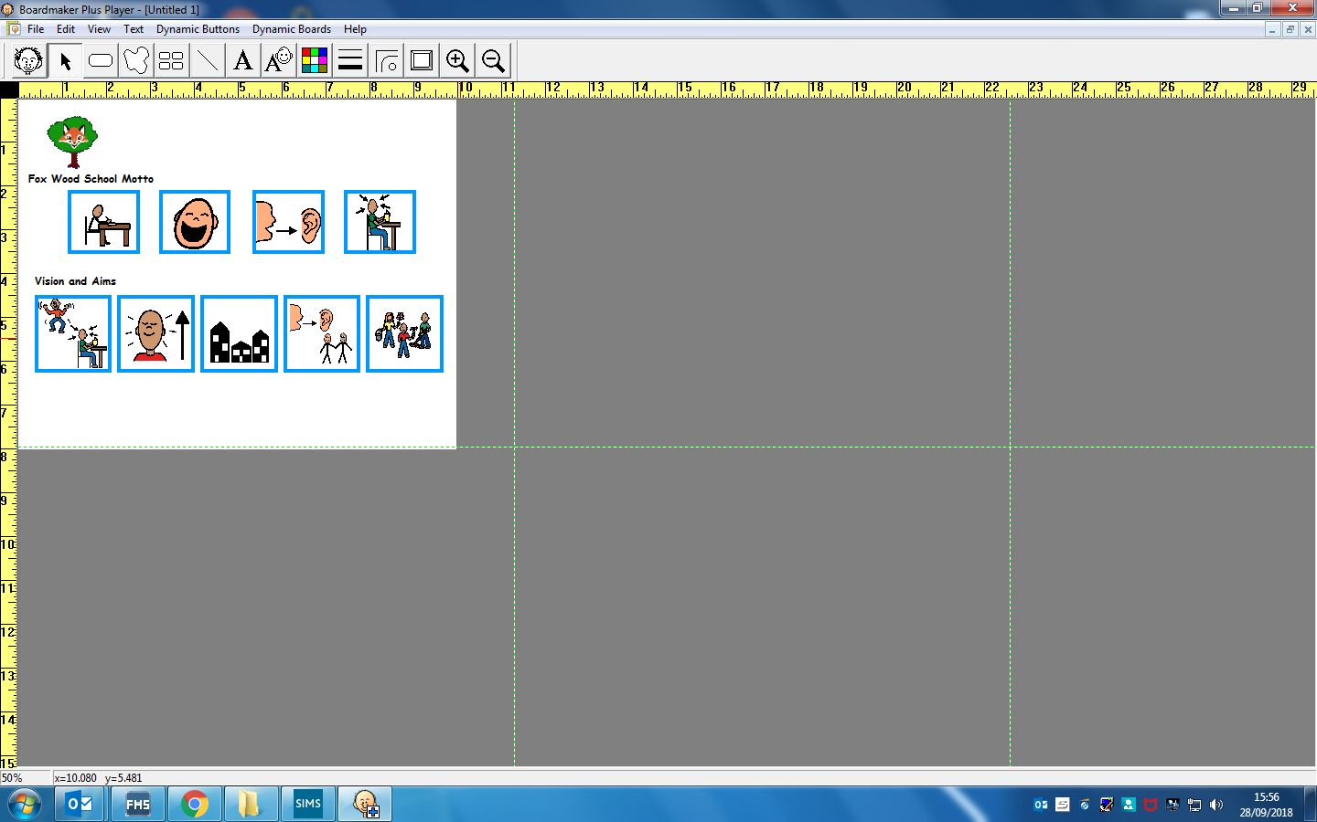

The school aims are:

* To provide high quality teaching which enhances learning opportunities at all levels
* To work in partnership with parents/carers to develop strong and effective links between home and school
* To provide a safe, stimulating, fun environment
* To promote self-esteem and respect throughout the whole school community and its multi-cultural society
* To provide a broad, balanced, appropriate and differentiated curriculum which supports pupils’ development and independence
* To promote meaningful partnerships with the local and wider community
* To develop strong, clear leadership and management at all levels

**SCHOOL DAY**

|  |  |
| --- | --- |
| 8.55 am | Pupils arrive at school & Registration |
| 9.10 am | Registers close |
| 9.10 – 9.30 a.m. | Morning routine/ready to learn |
| 9.30 – 10.30 a.m. | Lesson 1 |
| 10.30 – 11.00 a.m. | Snack and break |
| 11 – 11.45/12 p.m. | Lesson 2 |
| 11.45/12 – 1 p.m. | Lunch and break |
| 1 – 1.10 p.m. | Registration |
| 1.10 – 2.15 p.m. | Lesson 3 |
| 2.15 – 3.10 p.m. | Lesson 4 |
| 3.10 – 3.25 p.m. | Collective Worship, preparation for home |

**Term dates are published each year on the school website.**

**TERM TIME HOLIDAYS**

Fox Wood School follows the statutory guidance set out by the Department of Education, “Working Together to Improve School Attendance” published in August 2024. All term time holidays are unauthorised.

**ABSENCE**

If your child is ill or unable to attend school for any reason, please telephone the school before 9 a.m. to explain your child’s absence and indicate how long they may be absent. The school phone number is written in the front of the home school diary. We need to have this information to complete the school registers correctly.

It is the policy of the school to contact parents if we do not know why the pupil is absent or to maintain links throughout an illness.

All schools have to distinguish between ‘authorised’ and ‘unauthorised absences’. An authorised absence (for sickness, medical appointments, religious observation) involves the parent/carer notifying the school. An unauthorised absence is when the school does not know why a child is absent or has not consented to the absence.

**STARTING SCHOOL AND TRANSITION**

**EARLY YEARS**

Fox Cubs staff liaise closely with Sandy Lane Nursery staff and private day nurseries, maintaining close links and follow a robust transition package. Fox Cubs staff will attend Annual Reviews for pupils who will be attending Fox Wood School and pupil visits take place to both sites. Our EYFS teacher visits potential Fox Wood pupils in their nursery setting from the spring term onwards.

Transition meetings are arranged for parents and staff from both settings in the summer term and dates for transition visits will be shared from school.

Other professionals may liaise with parents prior to pupils starting school, for example, the School Health Team discuss Health Action Plans and care needs.

Families of new pupils are invited to attend “Stay and Play” sessions in order to gain an understanding of how child-initiated learning sessions run.

**SCHOOL**

For pupils joining us during the School phase, Fox Wood staff will liaise closely with current settings and will design and follow a bespoke transition package based on the pupils’ individual needs.

School staff will visit the pupil in their current setting and at home. Transition meetings are arranged directly with parents/carers and will involve other professionals as required to ensure that all information is shared before the pupil starts at Fox Wood.

*“Fox Wood School has comprehensive programmes for transition from nursery stage and to college. The transition programmes into and onwards from school are based on sharing key information between professionals, and a progressive programme of visits which allow early development of personalised provision in school and college.”*

**[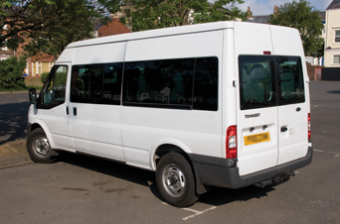](http://www.google.co.uk/url?sa=i&rct=j&q=&esrc=s&source=images&cd=&cad=rja&uact=8&ved=0ahUKEwiKpcLL5sXPAhVGXBQKHTilB_gQjRwIBw&url=http://deansminibuses.co.uk/minibus-hire/2894850&psig=AFQjCNF6f0kPL8eHlQhhirV8YGRwsNcz1w&ust=1475830341034604)SCHOOL TRANSPORT**

SEND school transport is arranged by Warrington Borough Council. In order to request and arrange school transport, parents need to ring 01925442627.

**PERSONAL CARE NEEDS**

Pupils’ personal and individual needs vary. All pupils are treated with respect and personal needs are met in a dignified and age appropriate manner, and supervised by staff where appropriate. If you require more information please refer to our intimate care policy on the school website.

All classrooms have access to a medical room and bathroom, most of which are accessed from the classroom. Staff nurture the pupil’s independence encouraging them to begin to complete personal care tasks as independently as possible.

**INFORMATION FROM SCHOOL TO HOME**

Throughout the year there are several events in school to which parents are invited, e.g. Meet The Team, Harvest assembly, Christmas events, themed weeks etc.

We also arrange appropriate training for parents to help them support their child e.g. Phonics, Moving and Handling, Behaviour Management, PECs, writing, assessment etc

Fox Wood has social media pages which we use to share teaching and learning activities, updates and reminders about whole school events. We also signpost to activities during half term holidays.



Fantastic Fox Wood

 @FoxWoodSchool

**HOME – SCHOOL COMMUNICATION**

Every pupil has a home-school diary which is written in at least 3 times a week by the staff team. We encourage parents to write in the diary with any current information the staff team needs.

Fox Wood use Evidence for Learning to share work and progress of pupils. We write IEP’s half termly and contributions are sought from parents.

Parents are invited to an annual parents evening and an annual review each year.

Laura Simms, our Pastoral Support Officer, is available to provide support and help make links Social Care and the wider community.

**HOME LEARNING**

Home reading books are sent home to all pupils weekly. We welcome the co-operation of parents in giving pupils the opportunities to practise their skills in a variety of settings including: sharing of books, cooking, dressing and hygiene skills, creativity or researching a topic. Class teachers will share information about the theme for each half term and suggest suitable home learning activities. Parents can request additional home learning activities at any time.

**UNIFORM**

The uniform is kept as simple as possible to avoid undue expenditure on the part of parents and to support the pupils with sensory issues. Please note the uniform is not compulsory.

**Primary - Key Stage 1 & 2**

White polo shirt

Red sweatshirt/cardigan

Black or grey skirt/pinafore

Black or grey trousers/ joggers

Summer Uniform

Red and white check dress

Red sweatshirt/cardigan

White polo shirt

Red sweatshirt

Grey or black shorts/trousers/ joggers

**Secondary - Key Stage 3 & 4**

as above but with Navy sweatshirt/cardigan, blue and white check dress.

Sweatshirts/Cardigans, Polo shirts and Coats/Jackets with school logo can be purchased through school.

**SCHOOL MEALS**

All pupils in Reception and Key Stage 1 are entitled to Universal Infant Free School Meals (UIFSM).

Many pupils are eligible for Free School Meals (FSM) and being eligible for free school meals is different from UIFSM. Even if your child is entitled to UIFSM they could also be entitled to FSM. FSM’s are linked to Pupil Premium Funding. Pupil Premium is additional funding given to raise the attainment of disadvantaged pupils and close the gap between them and their peers. Eligibility for free school meals is the main measure of whether a pupil is eligible for Pupil Premium. Please contact school for a form to complete if you would like to apply for this for your child.

**Alternative Feeding**

Several teaching assistants are trained in tube/PEG feeding. Training is provided by the school nursing team and staff are trained on each pupil that requires this.

**HEALTH CARE AND CLINICS**

Fox Wood has a school nurse on site, and clinics, such as bowel and bladder clinic, ophthalmologist, Paediatrician etc take place on site to maximise pupil attendance and to ensure they are seen in an environment that they are familiar with. The nursing team produce Health Action Plans for pupils with specific medical needs and these are shared with parents and the class team.

**CHILD PROTECTION/SAFEGUARDING**

The Designated Safeguarding Lead (DSL) is Lianne Buchanan (Deputy Head Teacher). Members of the safeguarding team are Lucinda Duffy, Laura Simms, Louise Messham, Jade Ashton, Lyndsey Phillips and Gemma Capper.

**ANNUAL REVIEWS**

These statutory reviews for every pupil are held throughout the year and are led by the Local Authority. Staff summarise pupil progress and comment on previously set objectives. We always involve the pupils in their Annual Review – they may be present if that is appropriate or they will have worked with the staff most familiar to them to share their voice, for example what they like to do at school, what they are good at and what they are working on. We follow a person-centred approach to reviews. There may be required amendments or additions to the pupil’s Educational Health and Care Plan and the LA will gather this information during this review.

**CURRICULUM**

We pride ourselves on adapting the National Frameworks and initiatives to ensure that our curriculum is constantly evolving to offer a range of opportunities and experiences.

The curriculum is delivered through four distinct ‘tiers’ and personalised learning is promoted for all pupils:

Pre-formal

Pupils working at this level will experience activities focused on the four main curriculum strands of communication, cognition, physical self-care and independence. Pupils engagement on the curriculum and activities will be tracked using The Engagement Model in 5 key areas – anticipation, persistence, initiation, exploration and realisation.

Pre-Formal Complex ASD

Pupils with complex ASD will experience activities such as; Attention Autism, multi-sensory learning activities, outdoor education, social skills, work baskets following the TEACCH approach. ​They will be supported to follow a structured carousel of activities, which will be based on the pupils’ interests.

Semi-Formal

Pupils working at this level will have separate lessons for literacy, maths, science, PSHE and PE. The foundation subjects will be delivered through a thematic curriculum.

Formal

Pupils working at this level will have a more ‘subject specific’ curriculum, with all subjects taught separately but still linked to an overarching theme. Modern Foreign languages will also be taught separately at this level.

In the secondary phase of the school (key stages 3 and 4) pupils will also benefit from sport and leisure and work related learning such as class-based enterprise and community work experience activities such as conservation.

Further curriculum information can be found on the school website.

**Preparing for Adulthood (PfA)**

PfA covers Employment, Independent Living, Community Inclusion and Health. PfA begins as soon as a pupil starts Fox Wood and all areas will be fostered, nurtured and encouraged.

**RELATIONSHIPS AND SEX EDUCATION**

As part of the National Curriculum we provide Relationship, Sex and Health Education (RSHE). The programme, which has been ratified by the Governors, is taught within a framework of the Personal, Social and Health Education (PSHE) curriculum. All lessons are planned carefully to meet the needs of individual pupils and are delivered in an age and stage appropriate manner. Please contact the school if you have any questions.

**COMMUNICATION**

We take great pride in having a Total Communication approach at Fox Wood. Staff are trained in basic Makaton signing, we use PECS, simple verbal language, objects of reference, photographs, symbols, intensive interaction, on body signing and a wide variety of apps/ communication devices. Some of these communication approaches are bespoke to the pupils and follow individual SaLT plans and other approaches are whole school approaches. Many pupils have a Speech and Language Therapy (SaLT) plan and school staff are trained by SaLT to deliver these plans.

**OFSTED**

Our most recent Ofsted was in 2021. The full report can be viewed via a link on the school website.

Comments made in the report include:

“Leaders ensure that pupils learn how to engage with others. Staff find the most effective way of communicating with each pupil. This enables pupils to develop confidence and independence.”

“Staff encourage pupils to ‘shine’. They have high expectations of pupils. Staff always expect pupils to attempt new, more demanding things.”

**NAS ACCREDITATION**

Fox Wood School has achieved ‘Advanced’ Accreditation status from the National Autistic Society in recognition of our specialist knowledge and skills. We are regularly reviewed to ensure that we maintain this status.

**GOVERNORS**

Our full Governing body meets at least three times per year, and meetings are convened by the clerk, who takes direction from the governing body, the chair and the headteacher. Please see the school website for more details.

**SCHOOL COUNCIL**

class elect a representative each year to attend half termly School Council meetings. The School Council discusses a range of topics including fundraising, supporting whole school projects such as Eco Schools, new equipment they would like to have at school and whole school events such as curriculum enrichment weeks and whole school celebrations.

**WORK RELATED LEARNING (WRL)**

We have a designated full time Level 3 Teaching Assistant who promotes Work Related Learning and Work Experience. Pupils have lots of opportunities for WRL including internal work experience, doing jobs (such as taking the register to the office), work environment experience and external work experience opportunities.

**TRANSFER TO 6TH FORM COLLEGE**

From year 9 students will have the opportunity to visit and familiarise themselves with the 6th Form College. This will be initially through informal visits and joint ventures, before a structured transition package is implemented. Parents, pupils, staff at school and college liaise closely throughout the transition period to ensure that this runs as smoothly as possible.

Transition to other colleges and provisions will be dependent on the chosen provision, and this will be fully supported by Fox Wood staff.

We hope you have found this prospectus useful and that it has answered any questions you may have at this stage. Further information will be provided once a place has been allocated and a transition package will then be finalised.

