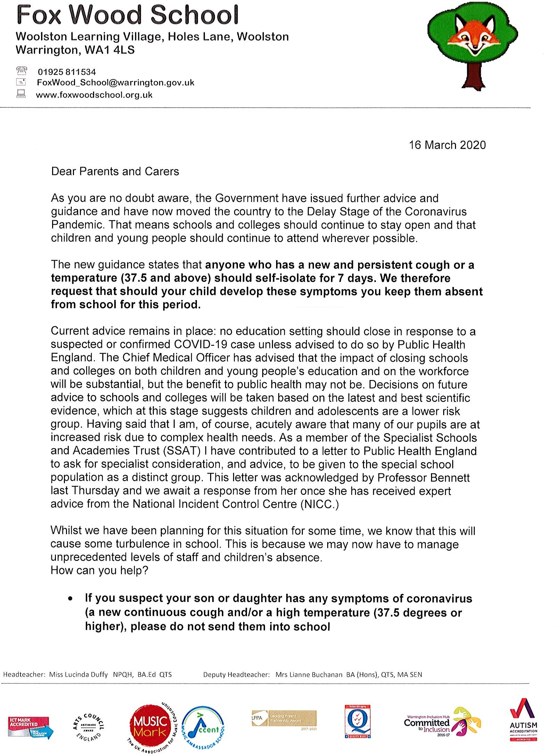

Dear Parents and Carers,

We write to update you on how we intend to respond to the current situation regarding the Coronavirus outbreak.

As I am sure you will appreciate, we are dealing with a complex and rapidly changing situation. Fox Wood School will remain open for the time being, unless specifically instructed by Public Health England to do otherwise, or in the event that we are unable to maintain appropriate Health and Safety standards. This is an unprecedented situation and we are following advice on a daily basis from the Department for Education and the Department for Health.

In response to current guidance, all off site educational visits have been cancelled and, regretfully, we are cancelling major gatherings across the Learning Village. At Fox Wood this will include our whole school Easter celebration event which was scheduled for 27th March 2020.

In the event of high levels of staff absence, we may need to consider changing elements of the timetable and deploying teachers to different groups of children. We will endeavour to ensure that learning is disrupted as little as possible, and support pupils with any anxieties that this could potentially cause.

If pupils feel unwell in school, we will follow the usual school procedures and parents/carers will be contacted. If your child is presenting with symptoms at home, then please inform us in the usual way via the school office. Should symptoms be those associated with Coronavirus (a high temperature or new persistent cough) then pupils must be supported to self-isolate at home for fourteen days, in line with the most recent Government advice.

While the school remains open, teachers will add home learning activities and letters to the school website which can be downloaded by parents as required for pupils who are required to self-isolate. Our website can be found at:

<http://www.foxwoodschool.org.uk>

In the event of a school closure, activities will also be provided via Evidence for Learning, our online learning journal. Log in in the usual way and when you view your child’s work, there will be pieces of ‘evidence’ from the class team with suggested activities. We will be inviting parents/carers to upload their child’s work on the activity so that the teacher can include this work in your child’s learning journey. Please let the school office know if you need your password reset for Evidence for Learning as soon as possible.

Please ensure that you keep checking the school website and our Social Media accounts regularly and we will do our best to keep you updated. All future letters will go onto the school website so checking this regularly will ensure that you keep updated.

If you do not have access to ICT equipment that enables you to access the above, then please let us know and we will see if we can find a way to support you. We very much want all pupils and families to keep a link with us, and to know that we are supporting you – even if this has to be remotely.

We trust the information outlined in this letter is helpful and reassuring, please do not hesitate to contact school if we can be of further assistance at this time. We will continue to update you as far as possible.

I recognise that this is an incredibly difficult time within school and college, for our families, and beyond. However, it is also a time which reminds me of what a strong and supportive community we have built together, and the exceptional dedication of all of our staff who are working hard both to support those children who are able to access school at this time, but also to prepare resources for whatever the future may bring.

Thank you for your continued support and for making the world a brighter place, even in the darkest of times.

Yours Faithfully,

Lucinda Duffy

Headteacher

