Sensory Play Ideas for Touch.

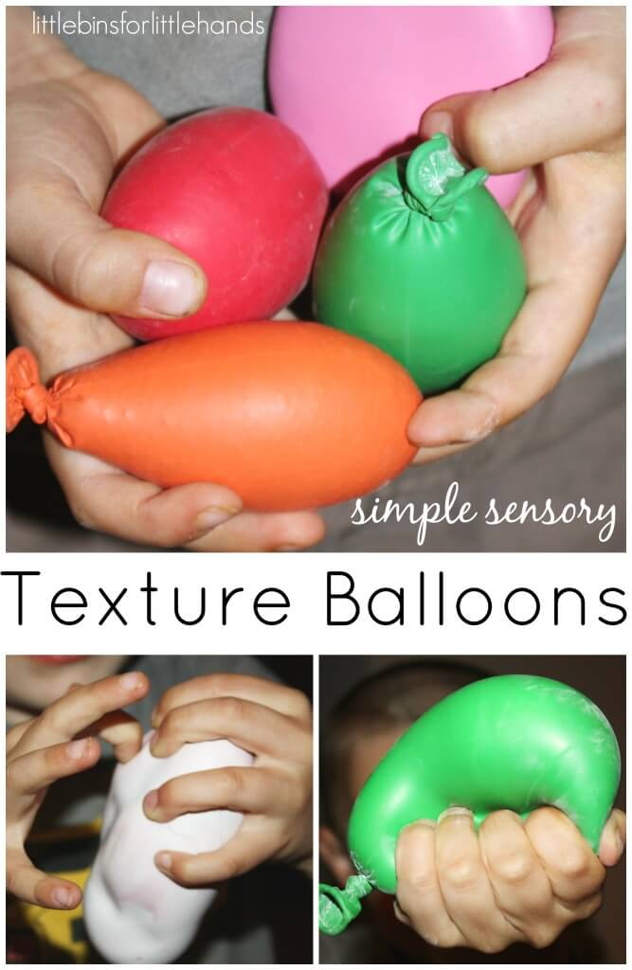

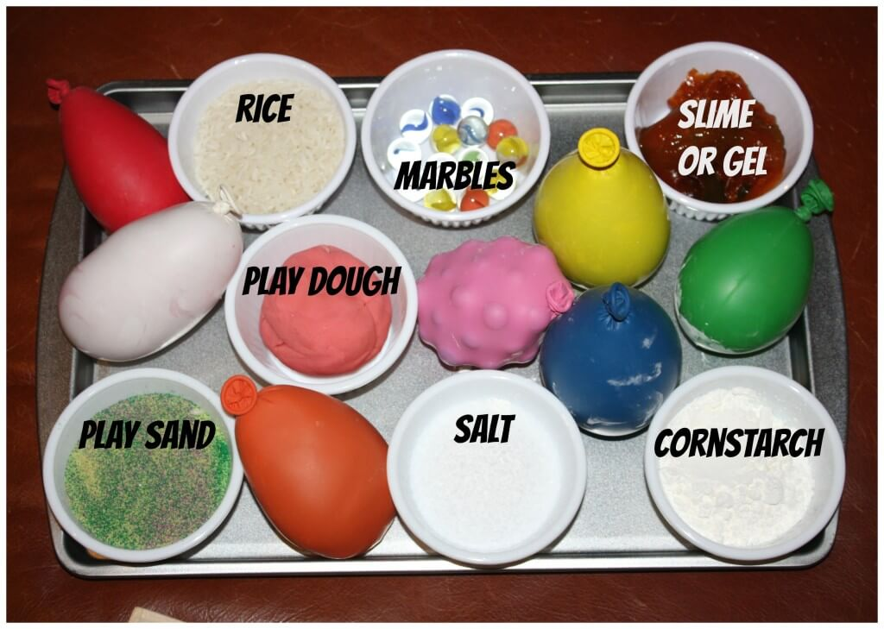

Texture balloons are pretty awesome and easy to make. Fun filled sensory balloons that you can make at home. They are surprisingly tough and can take a good squeeze.

What Is Tactile Sensory Play?

Tactile sensory play is all about touch! Wet or dry, cold or hot, vibrations and sensations. It can go way beyond a sensory activity. Some children do not like to feel everything and some materials are aversive. The fingertips are powerful sensors and the skin is the largest organ of the body! Some children have to touch everything and some avoid anything messy or different feeling. All children like to explore, discover and experiment with their surroundings and sensory play does just that.

Materials needed

Balloons (dollar store works fine)

Fillers: Sand, Salt, Corn-starch, Marbles, Play Dough, Rice, and something slimy (gel works)!

Air power or a good set of lungs

Funnel

The best advice is to blow up your balloon and let it hold air for a minute. This really stretches the balloon to make for a larger texture balloon.