Colour and smell of the day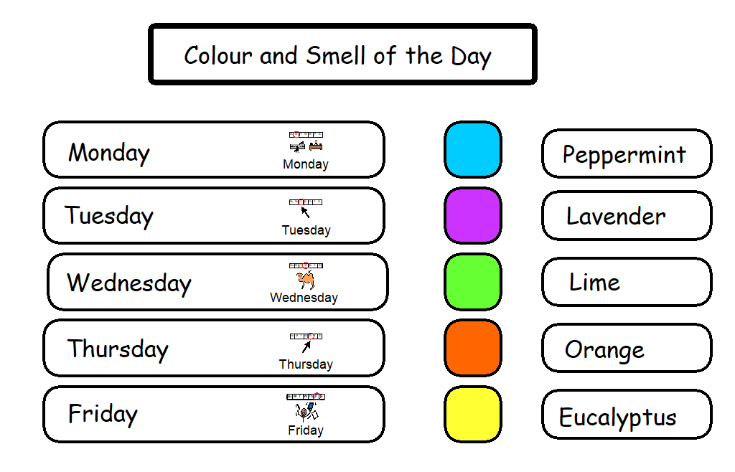
Each day classes explore the same smell and colour.
This can be done at home too by exploring your own local environment. Finding coloured flowers in the garden, smells in the kitchen, coloured toys and clothes.

