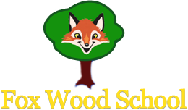

Parent / Carer Information

Class: 3 Term: Spring 1

In Literacy, we will be learning about the story of Rapunzel. Pupils will have the opportunity to take part in role play, using props, switches and visuals to support and learn all about the characters. Pupils will take part in character descriptions and work on their writing skills. The focus will be patterns and letter formation.

Our theme this half term is Turrets and Tiaras.

We will be exploring all things Royal from the past and present and linking this to some more familiar stories that include Kings and Queens.

Parents can help us by using positional terms such as in, on, under and reading stories about and/or including Turrets and Tiaras.

In computing, we will be exploring the different parts of a computer. What parts we use all the time and what parts we can see but don’t touch.

In Science, we will be expanding our knowledge of materials and how to use them appropriately. We will use prior knowledge to take part in investigations and experiments. Such as; which material works to build a kite, a boat or a bridge and why?

In Maths, we will be learning about prepositions through placing characters from our stories in, on, under and next to. We will be learning about size and length and measuring objects and our peers to compare different heights.